COMPONENTS

Components are handy stored MovieClips – see below for examples. To use a component you drag one on stage and set its parameters. To turn a MovieClip into a component, you save it as an .swc file by right clicking it in the library and chosing export to SWC. You have to write code using AS2 Classes. There are other tips that will help you in articles like this one:

http://www.person13.com/articles/components/creatingcomponents.html (detailed – not the simplest)

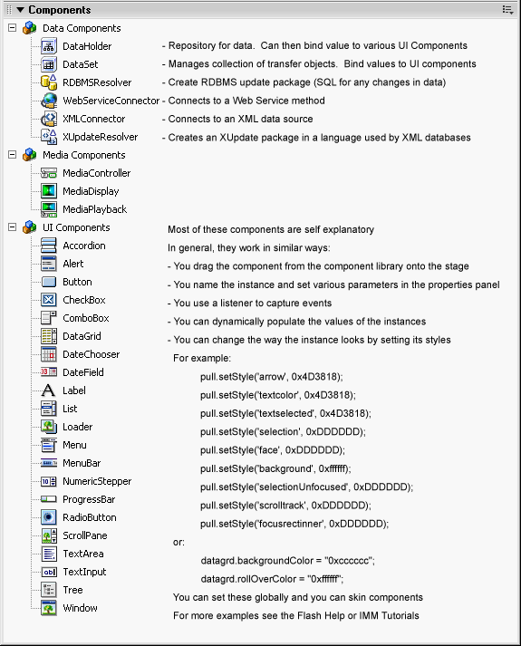

Here are examples of styles that are usually supported. Use: instance.setStyle('style', value);

Style | Description
backgroundColor | The background of a component. This is the only color style that doesn't inherit its value. The default value is transparent.
borderColor | The black section of a three-dimensional border or the color section of a two-dimensional border. The default value is 0x000000 (black).
borderStyle | The component border: either "none", "inset", "outset", or "solid". This style does not inherit its value. The default value is "solid".
buttonColor | The face of a button and a section of the three-dimensional border. The default value is 0xEFEEEF (light gray).
color | The text of a component label. The default value is 0x000000 (black).
disabledColor | The disabled color for text. The default color is 0x848384 (dark gray).
fontFamily | The font name for text. The default value is _sans.
fontSize | The point size for the font. The default value is 10.
fontStyle | The font style: either "normal" or "italic". The default value is "normal".
fontWeight | The font weight: either "normal" or "bold". The default value is "normal".
highlightColor | A section of the three-dimensional border. The default value is 0xFFFFFF (white).
marginLeft | A number indicating the left margin for text. The default value is 0.
marginRight | A number indicating the right margin for text. The default value is 0.
scrollTrackColor | The scroll track for a scroll bar. The default value is 0xEFEEEF (light gray).
shadowColor | A section of the three-dimensional border. The default value is 0x848384 (dark gray).
symbolBackgroundColor | The background color of check boxes and radio buttons. The default value is 0xFFFFFF (white).
symbolBackgroundDisabledColor | The background color of check boxes and radio buttons when disabled. The default value is 0xEFEEEF (light gray).
symbolBackgroundPressedColor | The background color of check boxes and radio buttons when pressed. The default value is 0xFFFFFF (white).
symbolColor | The check mark of a check box or the dot of a radio button. The default value is 0x000000 (black).
symbolDisabledColor | The disabled check mark or radio button dot color. The default value is 0x848384 (dark gray).
textAlign | The text alignment: "left", "right", or "center". The default value is "left".
textDecoration | The text decoration: "none" or "underline". The default value is "none".
textIndent | A number indicating the text indent. The default value is 0.

