How to Create Dreamweaver Templates

Overview of Process:

I. Mapping to a workspace

II. Dreamweaver Interface

III. Define a Local Site in Dreamweaver

IV. Create a Template

V. Modify the Template

VI. Apply a Template to Your Web Pages

VII. Edit a Template-Based Page

I. Map to the Appropriate Webspace
Mapping will create a site structure and create your webspace

II. Dreamweaver Interface – see PDFs

III. Define a Local Site in Dreamweaver
Define the local site. The local site is the site structure that will contain your folders, assets, and files for a particular site. Dreamweaver will store all the files for a particular site.
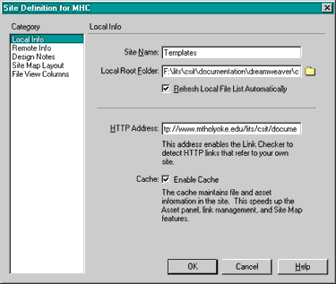

A. To define the local site:
- If it isn't already open, launch Dreamweaver. A blank document opens.
- Choose Site > New Site. A Site Definition dialog box appears.
- In the Site Definition dialog box, make sure Local Info is selected in the Category list.
- In the Site Name field, type the name of your site; i.e.: My Site.
- In the Local Root Folder field, specify the folder where your site is stored. Click the folder icon to browse to and select to the folder, or enter a path and folder name in the text field.
- Select Refresh Local File List Automatically to automatically refresh the local file list.
- Enter the URL that your completed Web site will use, so that Dreamweaver can verify links within the site that use absolute URLs.
- Select Enable Cache option. Caching the files in a folder creates a record of existing files so Dreamweaver can quickly update links when you move, rename, or delete a file.
- You must define a home page for your site before you can display the site map. The site's home page is the starting point of the map.
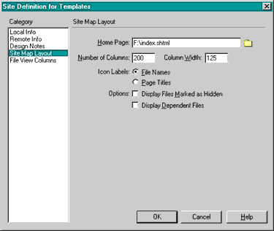
From the Site Definition for Templates dialogue box, select Site Map Layout; the dialogue box view changes as shown here.
- Click OK to close the dialog box.
- The Site window will then display a list of all the folders and files in the local site.
The list also acts as a file manager, allowing you to copy, paste, delete, move, and open files just as you would on a computer desktop.
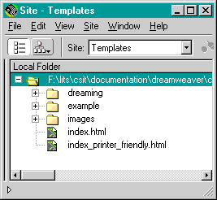

IV. Create a Template
You are now ready to create a template. You may either create a template from a blank page or from an existing page.

A. To create a template from a blank page:
- Open a new page in Dreamweaver.
- Incorporate the elements you want all of your pages to have, include navigation links and images accordingly.
- Select > File > Save as Template. The Save As Template dialog box appears.
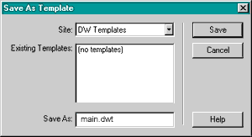
- In the Save As field, enter an appropriate file name for the template; for example: main. The file extension (.dwt) attaches automatically.
- Create editable regions in the template. See below, for more details.

B. To create a template from an existing page:
- Open the file you want to create into a template.
- Select > File > Save as Template. The Save As Template dialog box appears.
- In the Save As field, enter an appropriate file name for the template; for example: main. The file extension (.dwt) attaches automatically.
- At this point, the new template is the same as the page from which you saved the template so you will need to modify the template.

C. About links in templates
To create a relative link in a template file, browse for the file by using the folder icon, which is the yellow file folder to the right of the Point-to-file icon in the Property Inspector. DO NOT type in the name of the file to link to. If you type the name, the link may not work as expected.
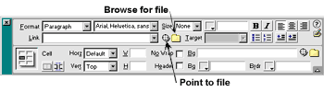
A relative link should be used if the file you want to link to is within the files you control. Otherwise, an absolute link should be used. An absolute link should be used when referring to someone else's HTML pages over which you have no control. An absolute link is the full Web site address, i.e.: http://imm.sheridanc.on.ca

V. Modify the Template
A template should contain both locked and editable regions. Locked regions can be edited only inside the template itself. Editable regions are placeholders for content that is unique to each page the template is applied. In template files, only editable regions are marked with highlighted outlines. You can make changes to both editable and locked content.

A. To create editable regions in the template:
- Place your cursor in an area you want to make editable, such as the area where your page heading will go, type the name of the editable area. If you have a specific size font, font type, or font color you want for this area, highlight the word and then select the desired font options.
- Highlight the name of the editable are you have just typed, then choose Modify > Templates > New Editable Region. The New Editable Region dialog box appears.
- In the Name field, type an appropriate name for this region of the template, such as Heading.
- Select OK. An editable template region is created. Notice the tab that contains the template region's name. The placeholder is also surrounded by a light-blue line that identifies the boundaries of the editable area. (The color may be a different color if Dreamweaver's default preferences have been changed.)
Note: If you want an editable area to have a specific font type, size or color, select accordingly before making the area editable. After you apply the template to a page, double click on the name of the editable area and then type over the name. This keeps the font preference as you preselected. If you paste text into the area, you will loose the preselected font.
- Repeat this process for all areas you want to make editable. Finalize and incorporate all the elements you want included in your template. If you find yourself repeatedly adding the same information or objects to a page, add them to your template.
The more structured elements you can include, the faster your pages can be produced. For example, you may want to include these items in your template: navigational links, heading, and footer information.
Use sample objects on the template. Many times you have to enter the same basic object on every page and only the filenames change. Enter your repeating object with all the preset parameters possible on your template page as an editable region, and you only have to select a new file for each page.
- Choose File > Save to save the template file.

VI. Apply a Template to Your Web pages
Now that you have set the editable regions in your template, you will use the template to create other pages.
- Choose Modify > Templates> Apply Template to Page. A Select Template dialog box will appear.
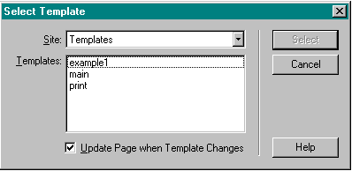
- In the Select Template dialog box's Templates list, select the template you want to apply to the new page.
- Choose Update Page when Template Changes and then choose Select. The template is applied to the new document.
This page contains the same regions and content as the template you created. Note: If you move the mouse pointer to a nonnegotiable region of this template, such as the logo or navigation button areas, the mouse pointer changes to indicate that you can't access the locked region.
- Save your document.

VII. Editing a Template-based Web Page

Now you will update the document you just created, updating the editable regions with assets and text appropriately. For example:

- In the Dreamweaver Toolbar's Title field, type the page title.
- Type the appropriate Heading, which may be the same as the Page Title.
- Add text and other information into the appropriate editable areas.
- Save your document.

