

Posting a Web site with Dreamweaver - A TRIO Training Tutorial
[Web Address: http://depts.washington.edu/trio/train/howto/page/dreamweaver/post/index.shtml]
The instructions below show how to upload to the TTQ server within Macromedia Dreamweaver MX 2004. Once you've uploaded your Web pages to a server, your team will be able to view them on the Web.
Dreamweaver users have two different ways to upload this year:
- If you have a small site and/or will only upload once or twice, use the instructions for Using WebDAV to Post a Web Site.
- If you have a large site and/or will upload multiple times, follow the instructions below. To use these instructions, you must already have a site set up in Dreamweaver (see our tutorial on Creating a Web site in Dreamweaver).
Before you begin, follow steps 1-6 in our Using WebDAV to Post a Web Site tutorial to connect to the remote server!
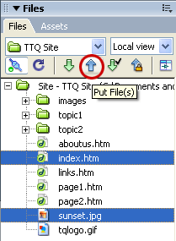
1. Open up your Web site in Macromedia Dreamweaver MX 2004.
2. With the Files window open (go to the Window menu and select Files if it’s not visible) and set to Local view, select the files and/or folders to upload. To select more than one file, hold down the Ctrl key on your keyboard and click to highlight each file (use Ctrl + A to highlight them all). Remember to transfer the images that you used along with the web pages. Click the Put Files icon to upload the files.
When prompted, enter your password. DO NOT check the Save Password box or other people who use that computer will be able to make changes to your site. Click OK and your files and/or folders will be uploaded.

3. To verify that your pages have been uploaded to the TTQ Server, switch from Local view to Remote view. All files and directories for your site will go inside of the public_html folder.

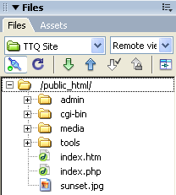
4. Make sure to visit your pages (via Web browser) after you are finished uploading and organizing your site. It is best to do this from a computer other than the one used to create your site. Check for broken links, missing image files, and other errors.

Viewing a TRIO ThinkQuest Web Site:
TRIO ThinkQuest sites may be viewed by typing the following address into your Web browser using your team’s username: http://dev.triothinkquest.org/username/
For example, if Team TTQ0001 uploaded a file named “aboutus.html” into the /public_html/ folder using the process above, they could view the file on the Web at http://dev.triothinkquest.org/TTQ0001/aboutus.html.
Teams must name their homepage file index with an appropriate file extension (e.g. .htm or .html) to ensure the homepage appears when Web users type in http://dev.triothinkquest.org/username/.
5. If needed, revise your Web site and upload again. Use the Put Files button to upload a few files or the entire Web site folder. If you have a larger Web site, it can take a very long time to upload every file. Consider using the Synchronize command instead. With this option, Dreamweaver compares your local files to the files on the server, and provides a list of new or changed files to upload.
To synchronize your local files with the files on the server, go to the Files window and select Local View, right-click (Mac users hold the Control key and click) on the root folder of your Web site, and select Synchronize....
The Synchronize Files dialog box appears. Next to Synchronize, select Entire Site. For Direction, select Put newer files to remote. DO NOT CHECK THE BOX for Delete remote files not on local drive (checking this option will delete important media and admin files included in your public_html folder). Click the Preview... button.
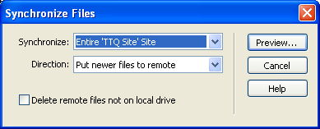
A list of new and revised files appears. Uncheck any files you do not wish to upload. Click OK and then click the Close button (do not click the Save Log button).
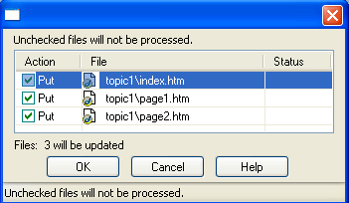
Visit your Web site to see if any additional changes are needed. You may need to click the Refresh button in your Web browser to view the changes.

