To use the Assets panel to create a new, blank template
- Choose Window > Templates.
The Assets panel appears, with the Templates category selected.
- In the Assets panel, click the New Template button at the bottom of the Assets panel.
A new, untitled template is added to the list of templates in the panel.
- While the template is still selected, enter a name for the template.
- This creates a new blank template in the Assets panel and in the Templates folder but does not create a .dwt file. To start defining editable regions, click the Edit button at the bottom of the Assets panel.
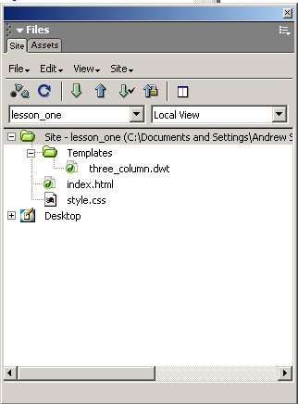

To edit a template file:
- Choose Window > Assets, then click the Templates icon to view templates.
The bottom of the Assets panel lists all of the available templates for your site. The top area displays a preview of the selected template.
- In the Name list, do one of the following:
  - Double-click the name of the template.
  - Click the Edit Template button at the bottom of the Assets panel.
- Edit the template in the Document window. Create editable regions in the template as desired.
- Save the edited template by choosing File > Save.
Note: If you haven’t defined any editable regions, Dreamweaver warns you that the template contains no editable regions. You can save or modify the template even if it doesn’t contain editable regions, but you won’t be able to modify documents based on that template until it has an editable region.
To apply a template to the active document:
- Open the document you’re applying the template to.
- Select the Templates category in the Assets panel, and locate the template you want to apply.
- Do one of the following:
  - Drag the template from the panel to the Document window.
  - Select the template and click the Apply button.
Note: You must assign the existing content in the document to an editable region of the template, or Dreamweaver discards the content.

To rename a template in the Assets panel:
- Click the name of the template to select it.
- Click the name again so that the text is selectable, then enter a new name.
Note: This method of renaming works in the same way as renaming a file in Windows Explorer (Windows) or the Finder (Macintosh). As with Windows Explorer and the Finder, be sure to pause briefly between clicks. Do not double-click the name; because that opens the template for editing.
- Click in another area of the Asset panel, or press Enter (Windows) or Return (Macintosh) for the change to take affect.
- Dreamweaver asks if you want to update documents that are based on this template.
  - To update all documents in the site that are based on this template, click Update.
  - To not update any documents that are based on this template, click Don’t Update. A document that you choose not to update is still based on the original template (not detached). To update this document later, open the document and choose Modify > Templates > Update.
To delete a template file:
- Select the template in the Assets panel.
- Click the Delete button and confirm that you want to delete the template.
If you delete a template file, you can’t retrieve it. The template file is deleted from your site. Documents that were based on this template are not detached from the template; they retain the structure and editable regions that the template file had before it was deleted.

Applying a template to an existing document
When you apply a template to a document which contains existing content, Dreamweaver attempts to match the existing content to a region in the template. If you are applying a revised version of one of your existing templates, the names are likely to match. Dreamweaver compares the names of the editable regions in the document to the names of the editable regions in the new template; for each region name that matches, Dreamweaver places the existing contents of that region into the new region with the same name.
If you apply a template to a document that hasn’t had a template applied to it, there are no editable regions to compare and a mismatch occurs.
Dreamweaver tracks these mismatches and lists them in the Inconsistent Region Names dialog box. You can then select which region or regions to move the current page’s content to, or you can choose to delete the mismatched content. If you want to keep the content, select the name of an editable region from the pop-up menu in the dialog box; otherwise, choose “nowhere”, which discards the unresolved content.
To apply a template to an existing document:
- Choose File > Open to open the document you want to apply the template to.
- Perform one of the following actions:
  - Click in the Document window, then choose Modify > Templates > Apply Template to Page. Choose a template from the list and click Select.
  - Select the template in the Templates category of the Assets panel, and click the Apply button.
  - Drag the template from the Templates category of the Assets panel to the Document window’s Design view.
- If content exists in the document that can’t be automatically assigned to a template region, the Inconsistent Region Names dialog box appears. It lists all the editable regions in the template being applied. Use it to choose a destination for the content.

Detaching a document from a template
To make changes to the locked regions of a document based on a template, you must detach the document from the template. When the document is detached, the whole document becomes editable.
To detach a document from a template:
- Open the template-based document you want to detach.
- Choose Modify > Templates > Detach from Template.
The document is detached from the template and all template code is removed.

