1. Create a new image 500x500 with a “transparent” background
2. Go Edit > Fill and choose “black.” Change the Background color to #3E6CAA and the Foreground to #76B6F4. Right click the background in the layer palette and choose “blending options.”
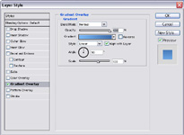
3. Create a new layer called “cloudsbase.” Press D to reset the colors. Go Filter > Render > Clouds. Go Filter > Render > Difference Clouds. Press Ctrl-F two times to repeat the difference clouds two times
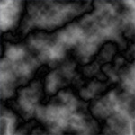
4. Press Ctrl-L to bring the lighting and use something similar to the settings below:
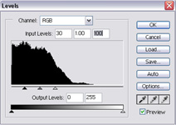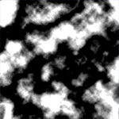
5. Duplicate layer “cloudbase” and rename the new layer “cloud3d.” on the new layer, Go Filter > Stylize > Extrude with the following settings:
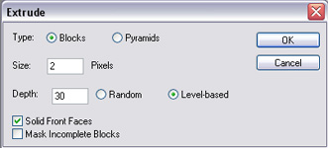
Change both layer “cloud3d” and “cloudbase”s blending modes to "screen."
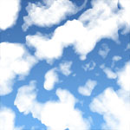
6. Choose layer "cloud 3d." Go Filter > Blur > Gaussian Blur with a power of one point six. (1.6)
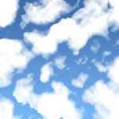
The clouds are decent at this point but they look flat. Time to air brush some shadows.
7. Take the brush tool and change its settings to what is shown bellow:
Make a new layer named “shadows”
The light will be coming from slightly above. Imaging you are looking up into the sky. The shadows on the clouds are going to be on the bottom of them. just follow the sample if you are confused.
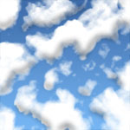
It does not matter at this point if your shadows are sticking out beyond the clouds into the sky.
8. Now, go Select > Color range. Change the Fuzziness to 118. click on a part you know has no clouds. Press ok.
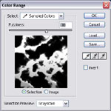
You should have a selection where the sky is and a little bit into the clouds. If you are not already on layer “shadow” go to it. Press delete. Change layer “shadows” opacity to 50%
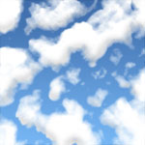
The clouds are starting to look very realistic. One more step! If you were looking at clouds from below, the clouds would not be that white. You are going to airbrush a showdown that covers the whole cloud except the edges that are above. It is a little confusing so please look at the image.
9. Create a layer named “shadow 2.” Take out the brush again and start shadowing the cloud. Be carefull not to shadow the top of each cloud. Also, don’t brush a place more than once.
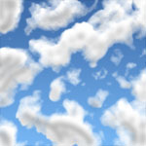
Go Filter > Blur > Gaussian Blur with a power of six point five. (6.5)
