Importing vector and EPS files into Director

Director supports a wide variety of graphic formats. Vector graphics are supported as native vector shapes (#vectorShape) or as Flash SWF files. Vector shapes are created in Director using the Vector tool. Often, developers need to import art created in an illustration application such as Macromedia FreeHand, Adobe Illustrator or CorelDRAW. However, EPS, AI, FH9 and CDR file formats are not natively supported in Director and cannot be imported without the use of an Xtra or plug-in.

EPS files may also be imported into Director using a third-party Xtra. The PS2VS Xtra from Moshofsky/Plant Creative Services for Director 7 and 8 works on both Macintosh and Windows operating systems. The Xtra can be downloaded from the Moshofsky/Plant PS2VS Web page. The current version converts Adobe Illustrator (EPS and AI files) and Macromedia FreeHand EPS files to Director 8 #vectorShapes.

Note: The PS2VS Xtra is a third-party product and is NOT supported by Macromedia or Macromedia Technical Support.

Using Illustrator

If you wish to create graphics in Illustrator to be used in Director, you should export the file as a SWF from Illustrator using: File >> Export and selecting Flash (SWF) file format.

In the case window, right click and selection “Import” and find the exported SWF file and select “add” | 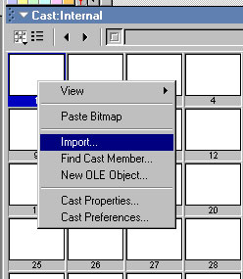
The cast member will be set as a Flash cast member with the “Flash” icon in the lower right hand corner. | 
The property inspector will show the a “Flash” tab and you can modify the cast member using the tab. | 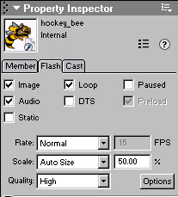
Once the sprite is on the stage, change the ink of the sprite to transparent for the background to become transparent. | 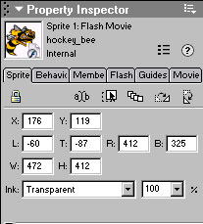

Importing Palettes in director

- Only one color palette is active in any single frame of your movie- current color palette
- When you create a 2-, 4-, or 8-bit image in Photoshop, a color palette is used to describe all colors in that image. This color palette is linked to the image file
- So when you import such an image into Director, you can import its linked color palette
- When importing an image from another program, such as Photoshop, the image should have its bit depth set before the import takes place

- To import a new color palette into Director

- Create a super palette – a super palette is an image comprised of all the images that will be used in the movie.

- To set a default color palette

- That is used automatically when you create a new Director movie
- This default palette is used as the current color palette in your frames until a new palette is set in the palette channel
- Modify menu- movie- properties- in pop-up menu select default palette- OK

Even though Director is capable of coverting one bit depth to another, the Quality is much better when the bit depth is detuned in the program, such as Photoshop, then imported to director.

Conflicting color palettes in Director movies
Only one palette can be active on your computer at a time. This causes problems in Director when you try to put two bitmapped cast members on stage at the same time that have different palettes; the colors for one of the images will be wrong.
While a movie is playing, the palette channel in the score determines the active palette. When the playback head reaches a frame containing a new palette, it changes the active palette. To make this change using Lingo you can use the puppetPalette command.
When a cast member you are placing on stage has a palette different from the currently active palette, Director adds the new palette to the palette channel. The new palette becomes the active palette, and it remains in effect until you set a different palette in the palette channel.
For example, if the winter scene mentioned earlier is on stage and you then add the tropical scene, Director places the palette for the tropical scene in the palette channel and the tropical palette becomes the active palette. The color references in the winter scene now refer to the warm colors in the tropical scene's palette and the image looks nothing like it did originally.

Solving color palette problems
Here are some general guidelines for avoiding problems caused by conflicting color palettes:
Make sure all cast members on stage at the same time refer to the same palette. This is essential.
Simplify your work and avoid frequent palette changes by mapping all the images in your movie to as few palettes as possible.
If possible, create a palette that contains all the colors you need in your movie. You can do this within Director by modifying an existing palette in the color palette window. You can copy and paste colors from one palette to another.

Before importing into Director you can create a “super palette” which is essentially an images with every color used in your images placed into one large image.

Outside of Director, you can use a conversion utility called Debabelizer by Equilibrium software (Macintosh only) to scan groups of images, create an optimal palette, and then remap all of them to the new palette.
Remap existing cast members to a new color palette using the Transform Bitmap command. See the next section, "Changing the palette of existing cast members."
As you import cast members, you can remap them to new palettes using the Image Options dialog box.
If you don't understand what has been discussed so far, or if you're using images with simple colors, you can avoid all of these complexities by using Transform Bitmap to remap all of your images to the Windows or Macintosh system palette.
Changing the color scheme in the Windows Display control panel has no effect on color display within Director.

Changing the palette of existing cast members
You can remap existing bitmap cast members to different color palettes with Transform Bitmap.
To change the color palette of bitmap cast members:
1 | Select the cast members you want to change in the cast.
2 | Choose Transform Bitmap from the Modify menu (Director 5) or the Cast menu (Director 4).
3 | Choose a new palette from the Palette pop-up menu.
4 | Choose either Remap Colors or Dither. Remapping replaces the original colors in the graphic with the most similar solid colors in the new palette. Dithering blends the colors in the new palette to approximate the original colors in the graphic.
5 | Click Transform to change the palette.

