- Export from Photoshop a high quality jpeg, where applicable:
- completed design
- background
- navigation – normal state
- navigation – rollover state
- navigation – down state

- Import each jpeg into your Director Cast. Set the color depth to 24-bit.

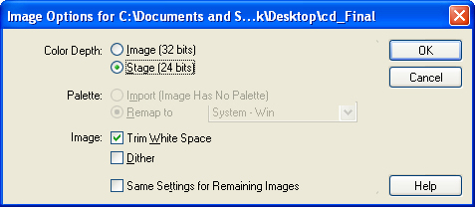

- In the Cast, duplicate the completed design or the jpeg with your navigation in the normal state.

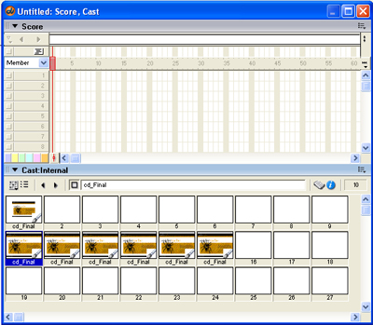

- Using the Director Drawing Tools, slice the navigation buttons from the rest of the design. Erasing everything but the buttons you require.
- When the dialogue box for launching an external editor “pops up”, click continue.
- Use the marquee tool to cut away the parts of the image that you do not need.

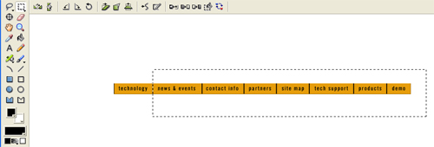

- Rename all of the images to correspond to the button or image name.
- NOTE: Do not change the registration point of the images.

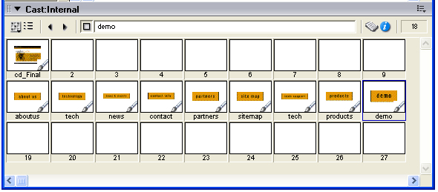

- Select the images. Select the first image, hold shift and select the last image. Then drag the images from the cast onto the Stage. All the images should line up on the stage with their Cast names visible.

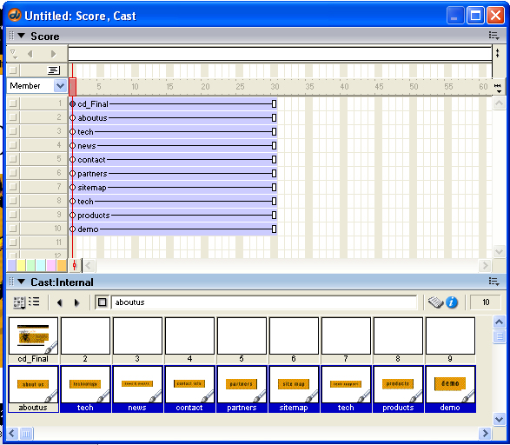

- All that is needed, is to apply an Behaviors or code to the buttons, etc. All the cast members will have the same registration point.

