SCANNING:

Turn on the scanner prior to opening Photoshop.

Place your image face down on the scanning bed.

In Photoshop go File >> Import >> “Select Scanner Name”

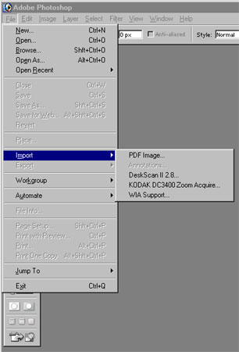

The scanner dialog box will pop up. NOTE: Window will be different depending on the scanner.

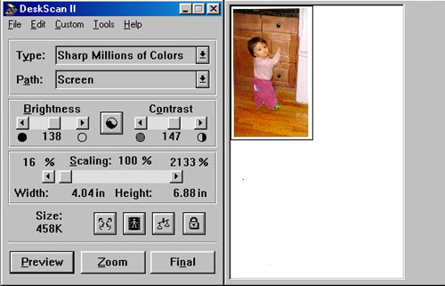

Scanner dialog box - shown after scanning. You can adjust the area, color and type of image using the dialog box then click >> Final or Save as depending on the software.

Scanning Tips:

- Scan larger than you need, approximately 150% of original size
- Decide on the dpi
  - 75 to 96 dpi for monitor
  - 150dpi for web & web documents (PDFs)
  - 300dpi for print
  - 300 dpi or higher for line art

NOTE: Since scaling (transforming) images in Photoshop is destructive, scan with the idea that you will me throwing out pixel information. So scanning larger and with a higher dpi is to your benefit.

Remember to take your originals with you. Backup original scan files.

Resolution, Pixel Count and File Size:

Scan  Resolution | 6x4 inch  Image Size  (pixels) | Pixel  Count | Memory size in bytes
Scan  Resolution | 6x4 inch  Image Size  (pixels) | Pixel  Count | Color | Gray Scale | Line art
75 dpi | 450x300 | 135,000 | 405,000 | 135,000 | 16,875
150 dpi | 900x600 | 540,000 | 1,620,000 | 540,000 | 67,500
300 dpi | 1800x1200 | 2,160,000 | 6,480,000 | 2,160,000 | 270,000
600 dpi | 3600x2400 | 8,640,000 | 25,920,000 | 8,640,000 | 1,080,000
1200 dpi | 7200x4800 | 34,560,000 | 103,680,000 | 34,560,000 | 4,320,000
2400 dpi | 14400x9600 | 138,240,000 | 414,720,000 | 138,240,000 | 17,280,000
4800 dpi | 28800x19200 | 552,960,000 | 1,658,880,000 | 552,960,000 | 69,120,000
9600 dpi | 57600x38400 | 2,211,840,000 | 6,635,520,000 | 2,211,840,000 | 276,480,000

