Pixel Stretching
Their ease of use, flexibility, and general funkiness when used properly makes them a useful tool for budding interface and wallpaper designers alike. Best of all, you can create them too in 3 simple steps...
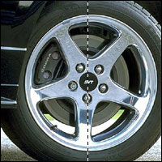 | Step 1: Open up a photo or picture of your choice. The best results undoubtedly come from symmetrical or 'head-on' images, but this is not always the case. Now, using the single column marquee tool (), make a 1px wide selection.
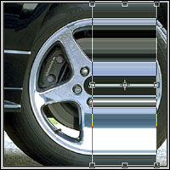 | Step 2: Select Edit > Copy from the Photoshop menu, and then Edit > Paste. This will create a new layer on top of the others, which you should now select in the layers palette. With this layer active, go back to the Photoshop menu once more and select Edit > Transform > Scale. Now move the cursor over one of the central nodes (little boxes) and click-drag it to either the left or right to create your stretch effect.
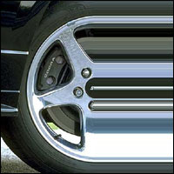 | Step 3: When the stretch is of the desired size, press ENTER on the keyboard to make the effect permanent.

