Multiple Part File: Part One

Part One: Background:

Create a Layer Set and name it background elements.

Background:

- Open a 800 x 600 work area, 72dpi, background transparent
- Insert a new layer – named “colored background”
- Open the Optimus Prime jpg and select one of the blue colors from the image.
- Use the “eyedropper tool” to select a blue
- Double click on the foreground color to one the color picker and select a color that is lighter than the color selected from the image.
- Go CTRL-A to select all on the colored background layer and ALT-Delete to fill

Creating a Fill:

- Open up a new 8 x 8 transparent image, and zoom in all the way.
- CTRL-A to select all.
- Select >> Modify >> Contract
- Contract by 1 pixel
- Will the Selection with White
- Edit -> Define Pattern
- Give the pattern a name and close the image without saving.

New Layer: Fill

- Create a new layer on top of your background and press ctrl+a (select all).
- Edit -> Fill. Choose your newly created pattern.
- Turn off the Layer.

New Layer: Barcode

- Create a new layer
- Choose the rectangular marquee tool.
- Make a selection with a height of 1px and the width of the work area.
- Fill in that tiny little selection with black.
- Go to Filter -> Noise -> Add Noise
- Make the Amount: 400%.
- Distribution: Uniform.
- Check the Monochromatic option.
- Still having the selection selected, press ctrl + T (transform) on your keyboard.
- Then just move the top part and bottom part of the selection to fill the work area
- Turn off the layer.

The only layers that should be on is the background color.

Grunge Layer:
- Using the scanned crumpled paper, create a grunge layer either from the layer or from the a “grunge brush”

Create a new Layer Set: Optimus BG

- Open the Optimus Prime JPG
- Duplicate the layer
- Turn off the first layer
- Select the “magic wand”
- Set the properties to:
  - Tolerance: 25
  - anti-alias – checked
  - contiguous – checked
- Select the white area and delete
- Move the cut out image into the Optimus Layer Set

Create a new Layer Set: Optimus Animation

- Duplicate the layer of the cut out Optimus Prime
- Move it into the Animation Layer Set
- Scale the image down to approximately half
- ALT-T to freeform transform
- Hold Shift&ALT to scale uniformly
- Or lock the chain in the scale toolbar and enter in a value
- Hit Enter to render the transform.
- Duplicate the layer
- Rename the layer Blur One
- Duplicate the layer
- Rename the layer Blur Two
- Duplicate the layer
- Rename the layer Motion
- There will be four layers:
  - Optimus
  - Blur One
  - Blur Two
  - Wind
- Blur One
  - Filter >> Blur >> Motion Blur: 15 or 20 pixel spread
- Blur Two
  - Filter >> Blur >> Motion Blur 30 or 40 pixel spread
- Motion Layer
  - Filter >> Stylize >> Wind
  - Select from Right
- Reorder the layers
  - Wind
  - Optimus – opacity 45%
  - Blur One
  - Blur Two
  - Move Blur Two to the right

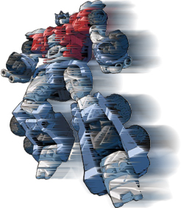

Create a new Layer Set: Race Lines

- Create a layer
- Turn on Rulers (CTRL-R)
- Using the move tool, bring down a guide into the lower third of the workarea
- Select one dark blue color from the Optimus image
- Flip the color to the background in the color picker
- Select one lighter blue from the Optimus image
- Using the Polygon Lasso tool draw a main race line and fill with the darker color
- Create a new layer
- Using the Polygon Lasso tool draw a race line and fill with the lighter color
- Report so there are race lines on both sides of the main race line

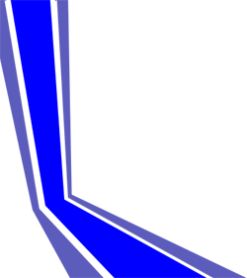

Create a new Layer Set: Autobot Logo

- Open the Autobot logo jpg
- Duplicate the layer
- Turn off the bottom layer
- Extract the logo from the background
- Using the Magic Wand
  - Select a blue region
  - Select >> Modify >> Expand
  - 2 – 5 pixels
  - delete
  - Select >> Feather
  - 1 pixel
  - delete
- Move the logo with transparency into the work area and move into the layer set
- Duplicate the layer
- Resize the logo to about a quarter
- Duplicate the layer
- Add Pixel stretch to the left

