Simple Masking
How to build a simple mask in Flash.
- Create a movie clip called “picture”
- Import an image into the PICTURE movie clip.
- Create a new movie clip called “mask” Draw a vertical rectangle. This will be your mask. You will need to plan ahead a bit and draw the rectangle with the registration point in the right position for you to scale the object. Place the rectangle so the registration point is on the left hand side of the object.
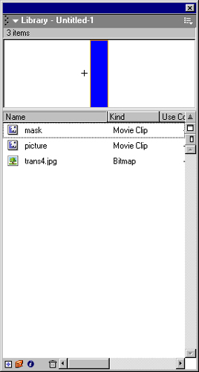

- With the library set, place the PICTURE movie clip on the main timeline and stretch the timeline to frame 15. To do this place the mouse in frame 15 and press F5.
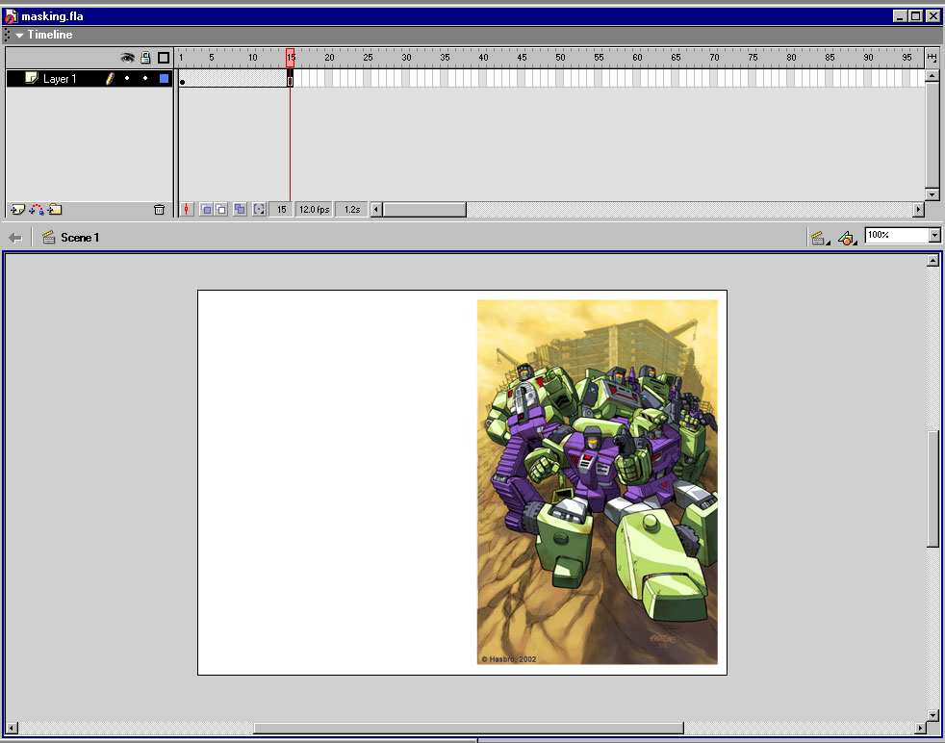

- Rename the layer – “picture”

- Insert a new layer above the picture layer and add the movie clip MASK.
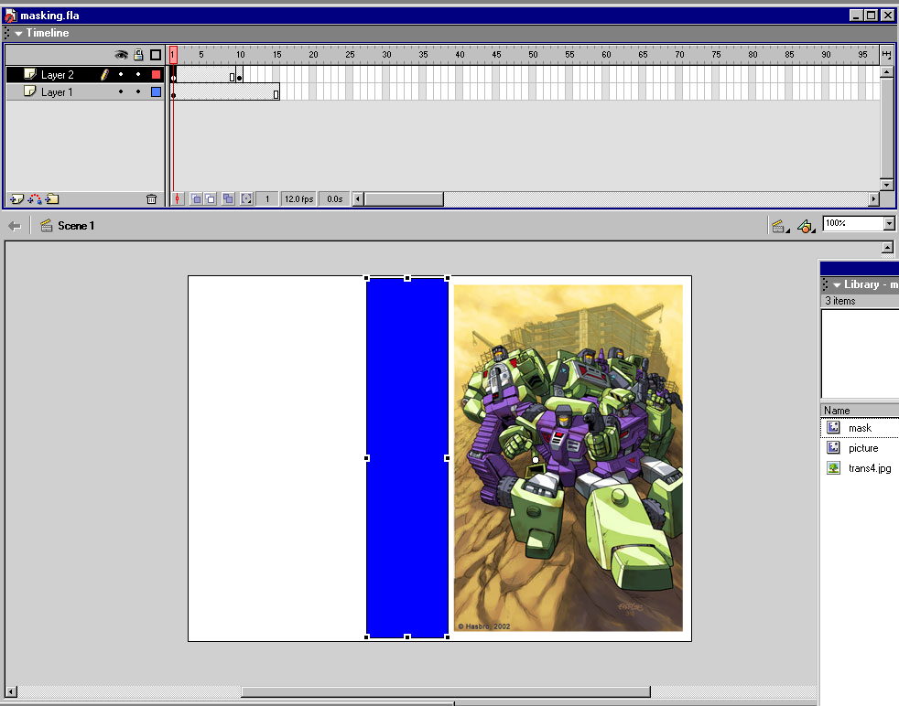
- Insert a key frame at frame 10. In frame, resize the shape of the mask to cover over the image in the layer below.
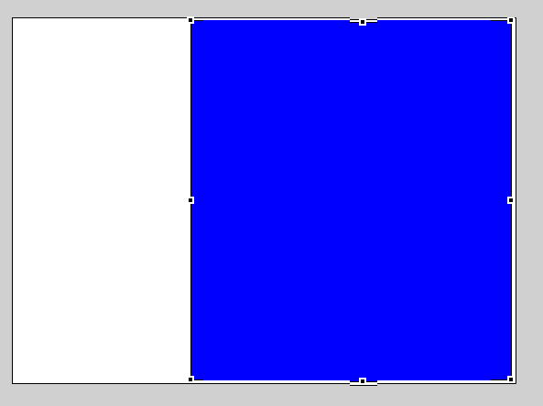
- Next create a motion tween in the MASK layer and view the animation. The mask movie clip should start on the left and then expand to cover over the image.
- Once you have the animation in place. Right click on the MASK layer and change its properties to “mask”.
- The mask layer will be locked to the picture layer, with the picture layer indented.
- So what is happening on the timeline, is that the mask is to small to show the image and as the transform tween moves across the image, it reveals what is underneath it. After frame 10, the image is shown without a masking layer above it.
