Color Correcting Images

1. Open an image you wish to color correct.

2. Make sure the “INFO” tab is active in the display palette.

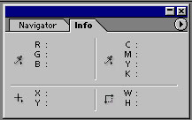

3. Select the Eye Dropper or Color Sampler (second Eye Dropper Tool) from the Tool Bar.

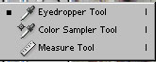

- The Eye Dropper gives you one color location
- The Color Sampler allows you create a history of locations

4. Image > Adjustments > Levels (Ctrl+L)

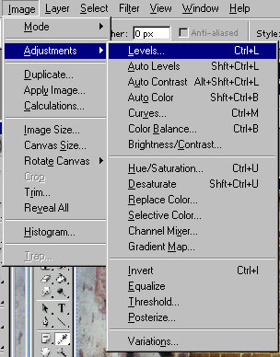
5. This will open up the Levels dialog box.

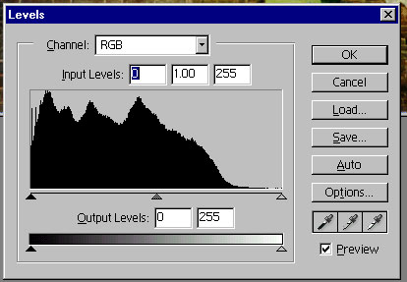

IMPORTANT NOTE: Always start with Black then to White, do not use the midpoint dropper.

IMPORTANT NOTE: Do not use Auto Levels.

6. Using the Eye Dropper or Color Sampler find the blackest part of the image. The INFO palette will give you RGB values. Try to find an area that brings all three values down to zero or as low a number value as possible. The image should become slightly darker.

7. Using the Eye Dropper or Color Sampler find the whitest part of the image. The INFO palette will give you RGB values. Try to find an area that brings all three values to 255 or as high a number value as possible. The image should become slightly lighter and closer to the true colors.

8. Adjusting levels creates an image that has true blacks and true whites represented in the color information.

9. Further adjustments to the image can be made using CURVES.

10. Image > Adjustments > Curves (Ctrl+M) – opens the curves dialog box.

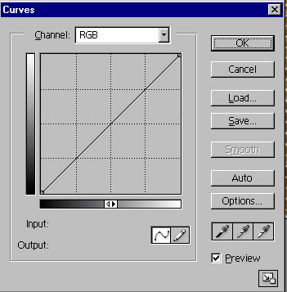

11. By changing the shape of the curve you will affect the light and dark tones of the image.

