Batch Processing in Photoshop
Introduction > Photoshop Prep > Batch Processing
To record an action, you'll need to use the actions palette. If the actions palette is not visible on your screen, open it by going to Window -> Show Actions.
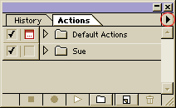
Notice the arrow at the top right of the actions palette. This arrow brings up the actions menu shown on the right.
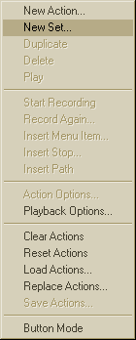
Click the arrow to bring up the menu and choose New Set. An action set can contain several actions. If you've never created actions before, it's a good idea to save all your personal actions in a set. Give your new Action Set a name, then click OK.
Next, choose New Action from the menu. Give your action a descriptive name. After you click OK, you'll see the red dot on the actions palette to show you're recording.
For this example I'm going to record an action to rotate an image. Go to edit and choose the rotate command, then go to the actions palette and hit the stop button (the black square).
Now you have an action!
To use the action in batch mode, you would go to File -> Automate -> Batch. You'll see the dialog box below:
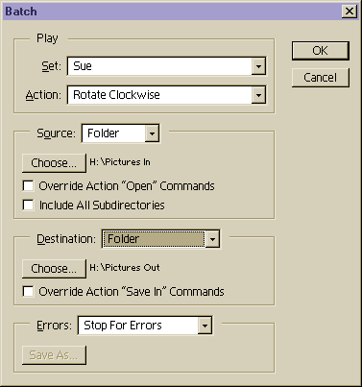
In the dialog box, simply select the set and the action you just created. For the source, choose the folder that contains the images you want to process. For the destination, choose another folder for Photoshop to output the rotated images. (You can choose "Save and Close" to have Photoshop save them in the source folder, but I don't advise it... it's too easy to make a mistake. It's much safer to use two folders and then delete the original files after you've made sure your batch processing was successful.) For errors you can either have the batch process stop, or create a log file of the errors. When you hit OK, you can just sit back and watch while Photoshop does all the work for you!
Once you have an action and you know how to use the batch command, you can use it anytime you have several photos you need to rotate. You could even do another action to resize a folder of images.

Copyright 2003 About.com http://graphicssoft.about.com/library/extra/blps_batch.htm

Batch Processing in Photoshop and Image Ready

Automating with actions

The actions palette offers a way to record a series of Photoshop operations and play them back in order, on a single file or a whole batch.

Actions are display by name in the actions palette. Within the palette they are grouped in sets, indicated by folder icons.

Important things about the palette:

- The small triangle to the left of action names is a toggle. Clicking it expands the set or action to show all it components, or collapses it to hide them.
- An action’s position can be changed simply by dragging the action’s name to a new position in the palette
- You can play an entire set of actions by selecting the set in the actions palette and clicking the play button. This makes it possible to assemble toolkits of actions that are appropriate for particular jobs. You can include the same action in several different tool kits if appropriate.
- A set can and should be permanently saved with the save actions command in the Action’s palette pop-up menu.
- An action can be moved from one set to another simply by dragging
- An action can be copied, either within the same set or to a different one by ALT-dragging to the position in the palette where you want the duplicate.

Recording Process

The actions recording process differs depending on whether you want to make a clickable button to choose a single menu item or whether you want to record a multi-step process.

- To turn any Photoshop command into a clickable button or an F-Key that chooses a command, open the actions palette and click the New Action icon at the bottom of the palette. Name the action and assign a color or function key shortcut if you like, and then click record. Choose Insert Menu Item from the pop-up menu and then select a command from a menu or sub-menu, or type in the command’s name as it is listed in the menu. Then click the stop record button.
Note: If the command includes a dialog box, the box should open so you can enter the settings you want, just as if you were choosing it from the menu.

- To record a multi-step operation so you will be able to apply the whole series of commands again, open a file representative of those you will be working on, and click the New Actions icon to start a new set. Name the action, click record and start performing operations.

What is “Actionable”

Certain commands and operation cannot be carried out using actions, because they are based solely on user input, but most commands and operations can be recorded and used.

- Brush strokes made with the paint tools (paintbrush etc.), the focus tools (sharpen and blur) and the toning tools (dodge, burn etc.) aren’t recorded. Instead you can insert a pause, complete with directions for what to do during the pause, so the user can stop and paint. To put a pause in the action, choose the insert stop command from the actions palette’s pop-up menu.
- Choices made in the layers, channels, Paths and history palettes can be recorded.
- Brush choices made from the Brushes Palette are recorded by position in the palette. As long as the there is a brush in that position when the action is played, that brush will be chosen. Commands from the brushes palette’s pop-up menu aren’t recorded.
- Choices made in the Options palettes for the tools aren’t recorded. Again, if you insert a stop command and directions so the person playing the action can make the appropriate settings.
- Paths themselves won’t be recorded as you draw them, but you can include a path as part of an action by drawing it, saving it in the paths palette with a unique name, then selecting the path in the paths palette and choosing the Insert Path command from the actions palette’s pop-up menu. When the action is played on another file, the original path will be added to the new files Paths palette, and further commands in the action can use that path.
- Some commands, such as changing preferences or color settings, showing a CMYK preview or gamut warning, zooming your view, or turning Snap to guides on or off, won’t record directly as part of a multi-step action. Instead this kind of command has to be recorded by choosing Insert Menu Item from the actions palette’s pop-up menu. Then choose the command, or type in the commands name into the Insert Menu dialog box, or type the beginning of the command an press the find button, which will supply the full name correctly spelled.

