How to Create 3D Wireframe Objects in Illustrator
by Aycan Gulez
aycan@wowwebdesigns.com
The blend tool can create amazing results in no time. As always no plug-ins required.
 | - Select the Ellipse Tool () by pressing L; hold down the Shift and Alt keys and draw a circle. Although this tutorial can be used for other simple or complex geometric objects, for the sake of simplicity, we will use a circle as our example.
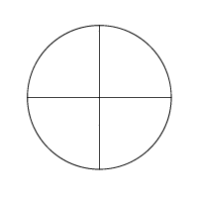 | - While the circle is still selected, press Ctrl+C to copy the circle to the clipboard, and press Ctrl+F to paste it in front of the original circle. Now double click the Scale Tool () to bring up its dialog box. Select Non-Uniform, set the Horizontal field to 0% and the Vertical field to 100%. Then click OK. This will create a vertical line in the center of your circle.  We will now repeat the above operation but with different Scale settings. Press Ctrl+F to paste the copy of the circle we copied a while ago in front of the original circle. Double click the Scale Tool to bring up its dialog box. Select Non-Uniform, set the Horizontal field to 100% and the Vertical field to 0%. Then click OK. This will create a horizontal line in the center of the circle, which is perfectly perpendicular to the vertical line we have created before.
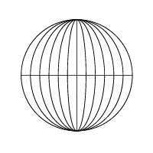 | - Double click on the Blend Tool (). Set the Spacing to Specified Steps, and the number of steps to 5 (you can increase or decrease this number as you see fit).  Press V to select the Selection Tool (). Select both the circle and the vertical line by clicking on them while holding down the Shift key. Press W to select the Blend tool, and click on the line and on any point on the circle but not the anchor points. This will produce the longitudes.
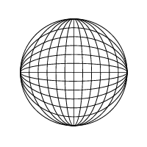 | - Now, we will make the latitudes. Press V to select the Selection Tool (). Select both the circle and the horizontal line by clicking on them while holding down the Shift key. Press W to select the Blend tool, and click on the line and on any point on the circle. Once again do not click on the anchor points, or you may get weird results. If everything went right, you should be done now!
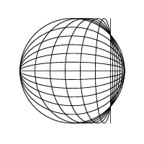 | - This step is optional. If you want to create some interesting looking shapes, try moving the lines producing the objects. But before doing so, save your work first since Illustrator may occasionally crash because of the complexity of the operation. In this particular example, I moved the vertical line in the center to the right with the Direct-Selection

