SPIROGRAPH USING ILLUSTRATOR:

This write up will show you how to create a spirograph effect using the pen tool and rotate object commands in Illustrator.

- Using the pen tool create a Bezier curve of any shape of your choosing.

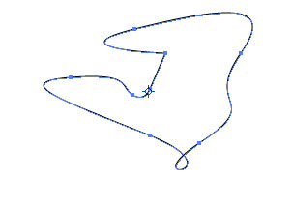

- First, select the curve using the Direct Select tool (black arrow).
- Using the Rotate Tool add a point of rotation onto the curve.

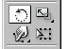

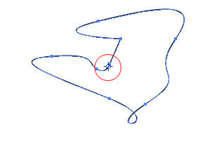

- Next, go to Object >> Transform >> Rotate

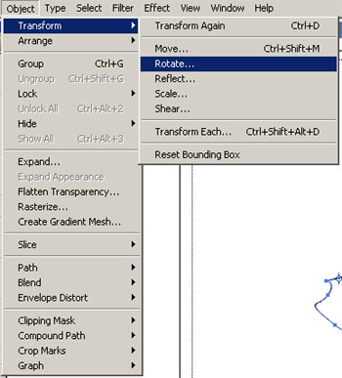

- The rotate dialog box will pop up and input a value of a multiple of 5 or 10. This is the degree offset that the item will be rotated.

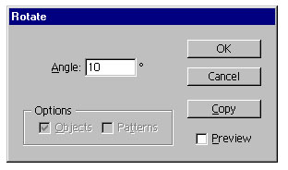

- NOTE: You must click the >>COPY<< button.

- After which, press Control-D to copy the rotating curve.

