Creating Vector Images from Photoshop:

Using paths in Photoshop you can create vector images from scanned images. This can allow you to create a vector file of clip art or logos when the client does not have a vector version to give you or from other scanned images.

You can also use this process to create outlines of images for utilizing in Flash.

- Download and open the Decepticon zip file.

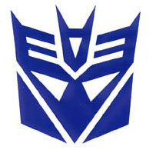
- Next is to add some blur to sharpen the edges of the logo.
Use Filter >> Blur >> Gaussian Blur

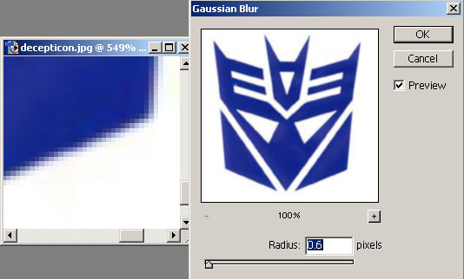

- Duplicate the layers and create an empty layer and reorder the layers as shown below.

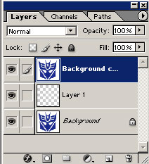

- Select the logo image using the Magic Wand tool

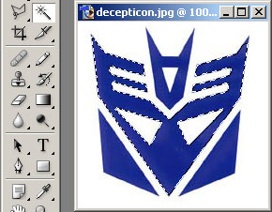

- Then Select >> Similar

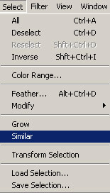

- Control Copy the Selection and leave the empty layer active.
- Go to the Channels palette.

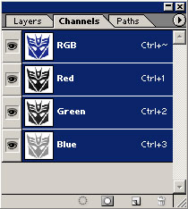

- Create a new Channel by click on the Arrow Button and selecting >> New Channel. Then paste the copy of the selection into the new channel.

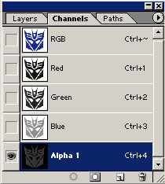

- Now go to the Paths palette

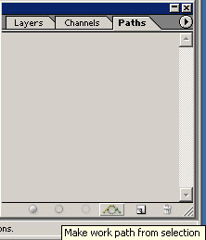

- Holding down the ALT key, press the “Make work path from selection” button at the bottom of the Paths Palette. This will pop up a dialog box.

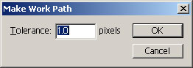

The lower the tolerance, the more detailed the curve will be.

- Go back to the Layers palette and you will now have the paths of the image

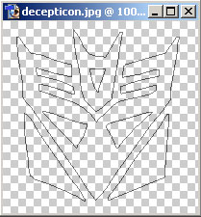

- Now export the paths to Illustrator.

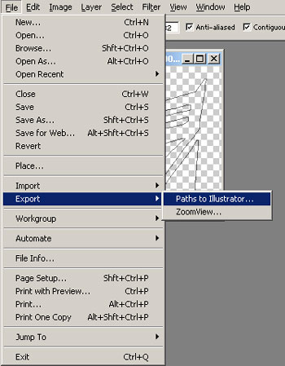

- Open the exported .ai file in Illustrator.

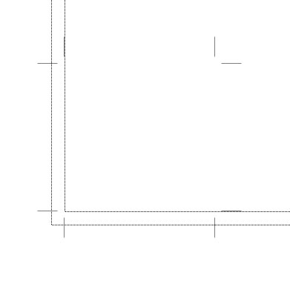

- Select All and fill the line work. You will have to modify the line work to show all the parts that need to be white. You can clean up the artwork using the Pen Tool to fix the art work by changing the Bezier curves and anchor points.

