PATHFINDER PALETTE

A few things are common to all the Pathfinder filters. First, if a filter produces a single object, that object will take on the appearance (fills, strokes, transparency, and effects) of the front object in the original stack. Second, if the filter produces multiple objects, those objects will be grouped. Third, if a Pathfinder filter is run on filled objects that aren't filled with solid colors, it might simply copy areas of objects when it should delete them.

Note: The concept of "stacking order" might be unfamiliar if you've never used a drawing program before. In Illustrator, each closed path is considered to be a separate object, and these objects can overlap and obscure one another. Whereas in Photoshop, stacking is determined entirely by layer order, in Illustrator, stacking can occur within a layer. Each time you create a new object, it appears on top of the stacking order, meaning that it will appear to be "in front" of other objects. You can move objects up or down in the stacking order by selecting them and then using an option from the OBJECT >> ARRANGE submenu, or by using the following keys: into holes and vice versa.

Ctrl + [ : send forward one step
Ctrl + ] : send backward one step
Ctrl + Shift + [ : send to front
Ctrl + Shift + ] : send to back

Add to Shape Area  Adds the area of the component to the underlying geometry. Its function is very simple: it takes two or more overlapping objects and combines them into a single object. | 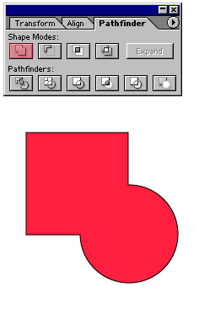
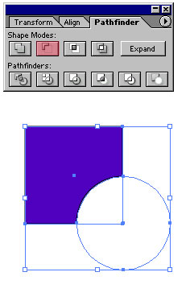 | Subtract from Shape Area  Cuts out the area of the component from the underlying geometry.
Intersect Shape Areas  Uses the area of the component to clip the underlying geometry as a mask would. | 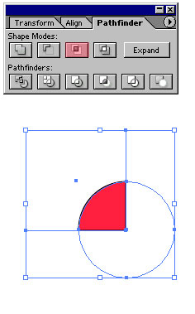
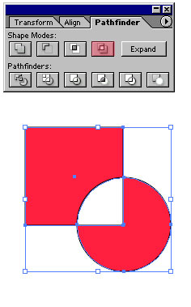 | Exclude Overlapping Shape Areas  Uses the area of the component to invert the underlying geometry, turning filled regions into holes and vice versa.
EXPAND – Creates a single object from the results of the Shape Modes.
Divide  Divides a piece of artwork into its component filled faces (a face is an area undivided by a line segment). | 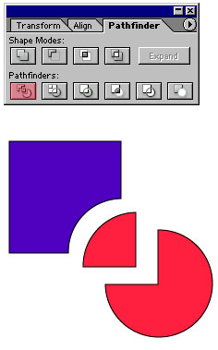
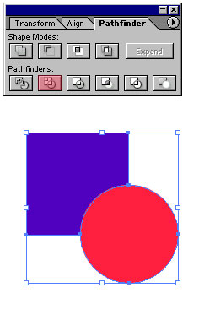 | Trim  Removes the part of a filled object that is hidden. It removes any strokes and does not merge objects of the same color.
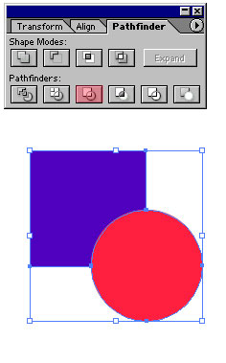 | Merge  Where overlapping objects have the same appearance (i.e. all fills and strokes are identical), this filter acts like the Unite filter. Where they differ, this filter acts like the Trim filter.
Crop  The Crop filter uses the frontmost object as a clipping path for the underlying objects. All areas of the underlying objects that do not overlap with the frontmost object are deleted. The frontmost object loses its fill and stroke, but remains as a reminder of the clipping path. There are very few reasons to use this filter, when a real Clipping Mask (OBJECT >> CLIPPING MASK >> MAKE or Ctrl+7) does the same thing, while allowing the clipping boundary to be edited. An interesting side effect: if you use the Crop filter on a group that already includes a normal Clipping Mask, the Clipping Mask will be deleted, taking the areas outside the mask with it. | 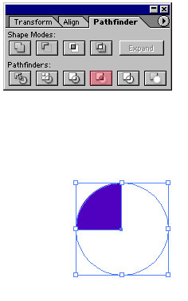
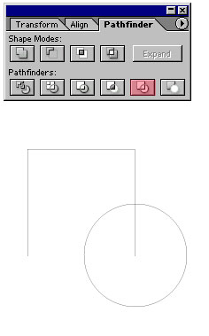  The shapes have lost their fill and stroke. | Outline  Transforms all closed paths to open paths, and slices those open paths along the lines of intersection. I've never found a real-world use for this filter, but I'm open to suggestions.
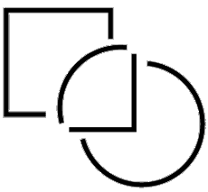
I've applied a black stroke to the paths, and pulled them apart so you can see what's become of them.
Minus Back  Subtracts the backmost objects from the front object. You can use this command to delete areas of an illustration by adjusting the stacking order. | 