Illustrator
Illustrator Tutorial Part 2 Author's Website: http://www.sorcerersworkshop.com/

Now that you have a fair idea of the vector toolset available in Illustrator 10 the question becomes what can you do with them. The answer is just about anything. In Part 2 I will demonstrate how you can edit, combine, subtract, join various shapes into more complex objects.
Scissor Tool Options
These two tools allow you to cut up a path.
Scissor Tool
You can split a path using the Scissors tool . Simply select any anchor point or any segment and it will cut the path. You can then use the 'Direct Selection Tool' to pull the new anchor points apart.
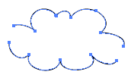
Knife Tool
This tool slices grouped and ungrouped objects along a freehand path (Hold down - Alt - for a straight cut) you draw, dividing the object into their component filled faces.
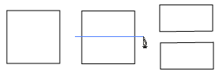
An example of the knife tool in action
Join Anchor Points
After cutting the path you can rejoin two anchor points. Select the two anchor points you want to join using the 'Direct Selection Tool' and right click. Choose the 'Join...' option. If the points are apart a segment will join the two anchor points. If the anchor points are occupying the same position you will get a smooth joining.
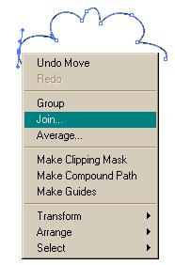

Average Anchor Points
If you wish to combine or average out several anchor points select them with the 'Direct Select Tool' and right click. Choose the 'Average ...' option. The two anchor points will be combined into a single point.
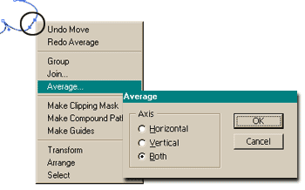
Add Anchor Points
Another way to add anchor points to a path in a more precise way is to use the 'Add Anchor Points' under the - Object - Path - submenu. New anchor points are added along a path equidistant between the original anchor points.
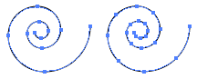
Simplify
Reducing the number of anchor points in any path without affecting the shape is equally easy using the - Object - Path - Simplify - command.
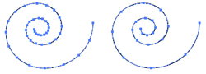
Offset Path
This is a great command. You can replicate a path, set off from the path by a specified distance. Using the 'Offset Path' window the paths are offset by distance, the corners can be mitered, round or beveled, and you can set the miter limit (for PBC residents miter limit controls when the program switches from a pointed join to a beveled join).
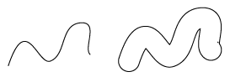

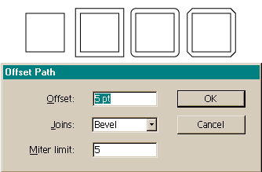
Clean Up
This command deletes unused type paths and containers from your artwork. You access it under - Object - Path - Clean Up.

Rotate Tool
This tool allows you to rotate an object or group of objects. The default setting is the object will rotate about its center. But by shifting the 'center point' around you can rotate an object from any location. You can also double click the tool and get a 'Rotate' window allowing the user to enter a precise rotational angle and whether you want to rotate the original object or a copy of the object.
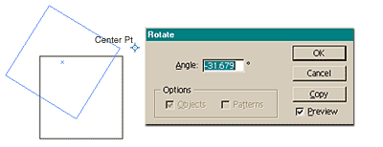
You can also rotate, scale, move and reflect a group of objects. Simply select the objects you wish to affect and go - Object - Transform - Transform Each.
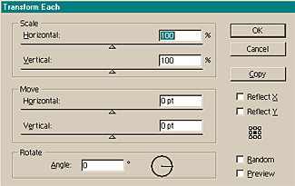
Twirl Tool
This tool rotates a selected object(s) more sharply at the center than at the edges.
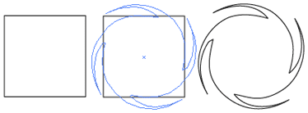

Scale Tool
This tool will enlarge or shrink an object(s). But by shifting the 'center point' around you can scale an object from anywhere. The - Shift - key will create a uniform scale (for those in PBC that means the shape of an object will not change, only its overall size).You can also double click the tool and get a 'Scale' window allowing the user to enter a precise scaling effect and whether you want to scale the original object or a copy of the object.
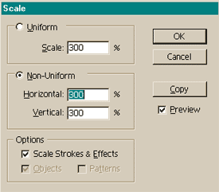

Reshape Tool
This tool allows designers to select one or more anchor points and adjust those points while keeping the overall detail of the object intact.
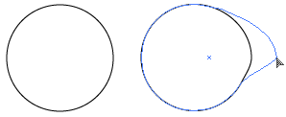
Reflect Tool
The Reflect tool flips an object(s) across an invisible axis you can specify. Holding the - Shift - key constrains the reflection to 90 degree increments. By double clicking the tool you get greater control on how an object(s) is reflected with the 'Reflect' window.
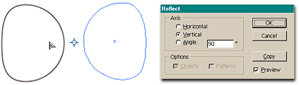
Shear Tool
The Shear tool skews objects along an axis you set. This tool is very useful for creating shadows of objects. By double clicking the tool you get greater control on how an object(s) is sheared.
