UTILIZING COLOR PALETTES:

When developing a color scheme for a design, you can develop the scheme using a limited palette of colors from a full color image using Photoshop and Image Ready.

By taking the image and “Save for Web” >> by saving in a GIF file format you can limit the color palette and use the new custom palette in both Photoshop and Flash.

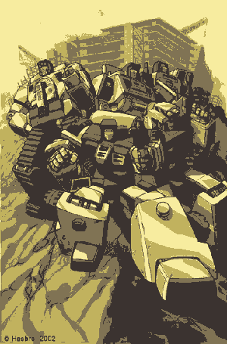 | 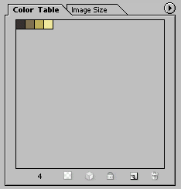  4 Colors palette
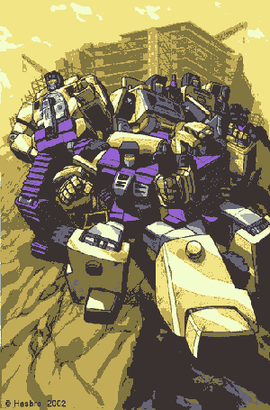 | 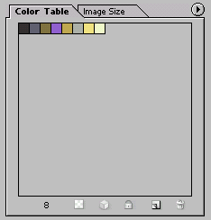  8 Color palette
 | 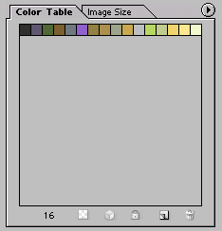  16 Color palette
 | 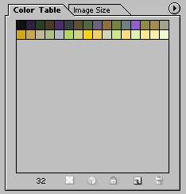  32 Color palette
 | 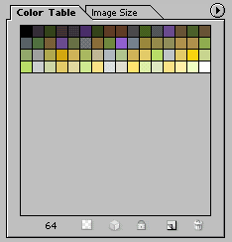  64 Color palette
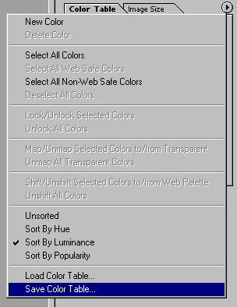 | Once you have finalized the color palette you wish to use:  - While in Image Ready, click on the arrow button on the color table.  - Select “Save Color Table”
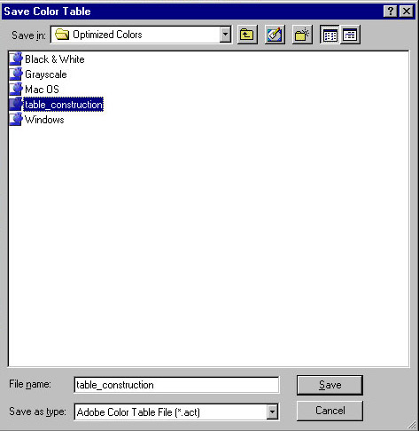 | - Name the new “Adobe Color Table File” (.act).
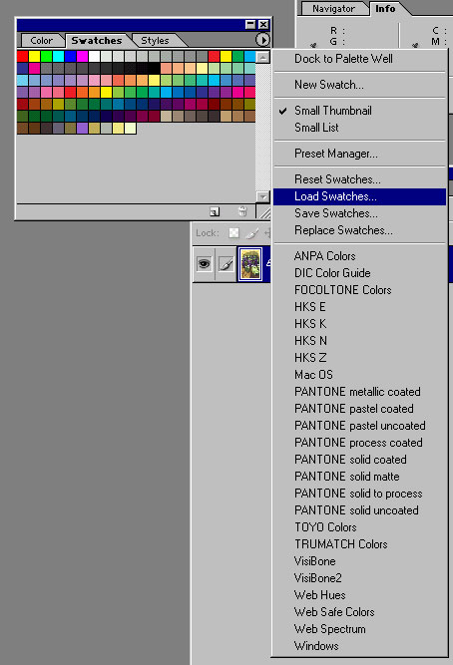 | - When you start a new file, you can import the custom color table information into your current color swatches  - Click on the arrow button on the color swatches palette and select >> Load Swatches  - Load the new (.act) file you created.  - You should have the custom colors adding to the color swatches.
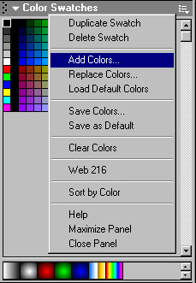 | Similarly, when using Flash you can import the custom colors from your project palette.  - In Flash, on the Color Swatch palette, click on the “additional information” button.  - Select >> Add Colors
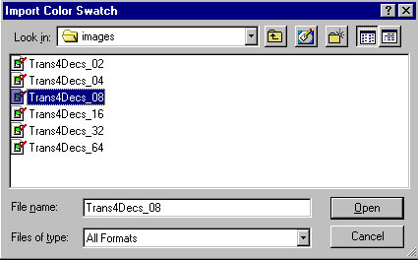 | - Locate the exported GIF file that has the custom colors.  - Click >> open
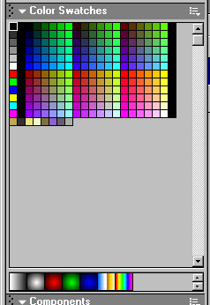 | You should have the limited colors from the image added to the Flash Color Swatch palette.  This will save time in have to type in hex values from Photoshop or elsewhere.

