ANIMATED BANNER AD:

- In Photoshop >> open a new file and select “Banner Ad” from the drop down menu.

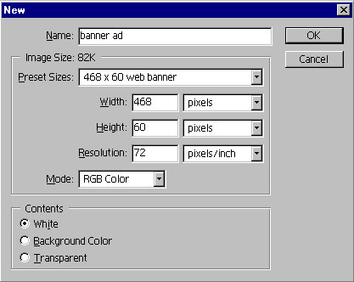

- Open the CBC logo and place it into the banner ad file. You may have to resize the image to make it fit properly.

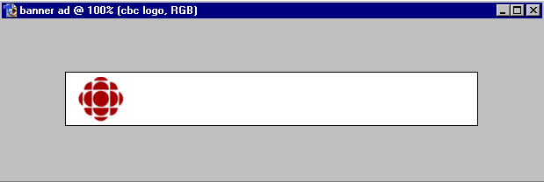

- Next make a copy of the layer with the CBC logo and add some “Outer Glow” layer effect to the logo.

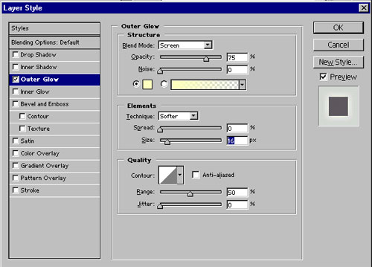

- On the original layer of the CBC logo add motion blur to the image.

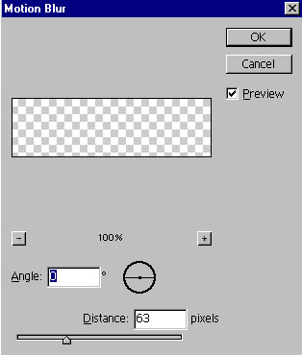

- Define a pattern for the lines using a 4 x 4 transparent square.
- Create a blank new layer and fill the layer with the fill pattern.
- Open the file “goalie_save.jpg” from Exercise 1 in Lesson Two.
- Bring the image into the banner ad and resize the image to fit the screen.
- Next Create a Text Layer with “Catch all the Action” and another text layer with “Hockey Night in Canada”.
- Then duplicate the two text layers and rasterize the layers by “right click” and RASTERIZE LAYER to convert the layer from text to pixel information.

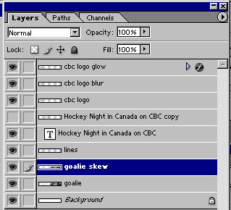

- Then add Motion Blur to the to layers of rasterized text.
- Once you are done. Turn off all the layers except for the layer with the line work fill.
- Then at the bottom of the toolbar, click the jump to Image Ready Button.

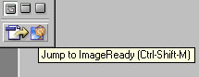

IMAGE READY

- Select the Animation Tab on the work bar.
- You can now animation by adding frames and turning on and off layers in the layers palette.

