Here are the instructions for the exercise done in the photoshop class.

- Download and unzip the file “hockey.zip” from the IMM 2004 site.
- Start Photoshop
- Start > Adobe > Photoshop > Photoshop 7.0

Setting up the work area:

- File > New (or ctrl-N)

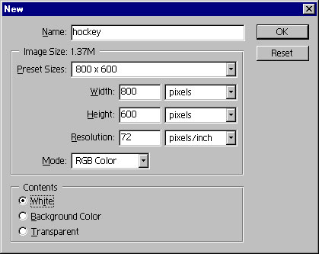

- Make sure you are set to RGB color from the dropdown menu and the resolution is set to 72 dpi, The background can be white for now.

With the new work area, create a new layer to start working on.

- Layer > New > Layer

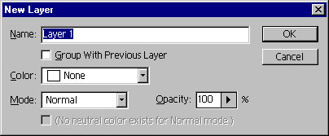

- Name the layer “top bar navigation” so you know what you are working on.
- Create a long rectangle at the top of the work area, this will be beginning of your top navigation.
- Fill the selection with a color of your choosing.

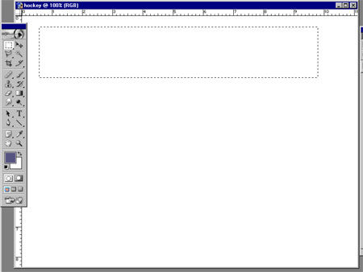

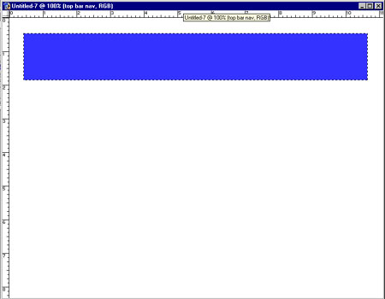

- Create a new layer and label it stroke
- Using the “Magic Wand” tool, select the top bar, make sure the top nav bar layer is active. Once you have the “marching ants” around the top bar shape, make the stroke layer active.

- Now you will modify the selection by: Select > modify > contract

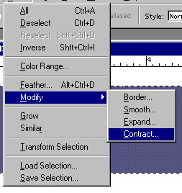

- Use a value between 5 and 10 pixels
- Now you will add the stroke.
- Select a color that is different from the color of the top bar nav. Refer to the hand from class to the color selector.
- Now use Edit > Stroke
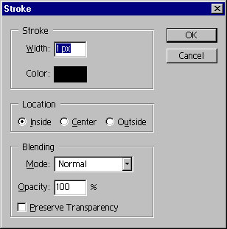

- Make sure the “Preserve Transparency” is unchecked.
- Say OK

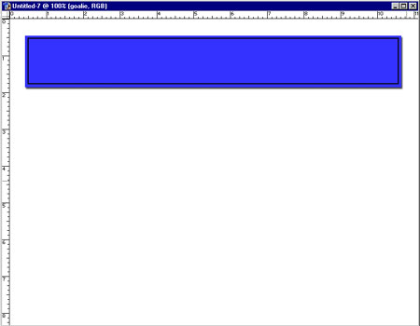

- Add a drop shadow to the top bar nav layer. Make the top bar layer active and select the “F” in a black circle at the bottom of the layers palette.

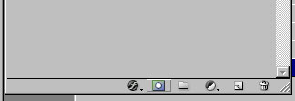

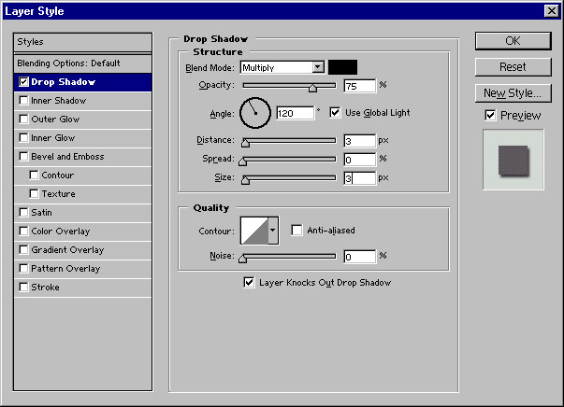

- You can change the distance and size to your liking.

- Import an image from the images provided or use your own.

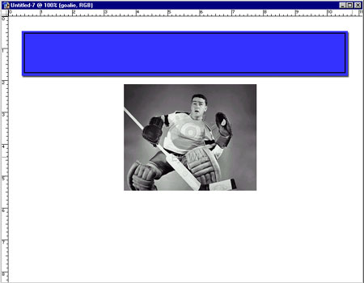

- Move the image so that is it on the top bar nav. Reorder the layers in the layers palette so that the new image is above the top bar nav layer but below the stroke layer.

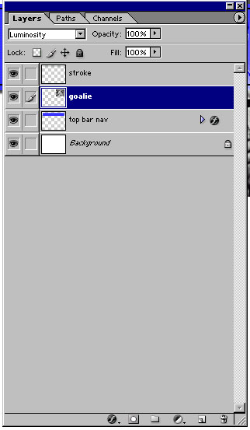

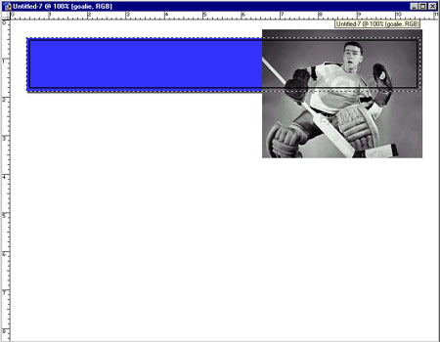

- Using the “Magic Wand” tool, select the top bar, make sure the top nav bar layer is active. Once you have the “marching ants” around the top bar shape, make the new image layer active as above.

- Now select the “Mask” at the bottom of the layers palette.

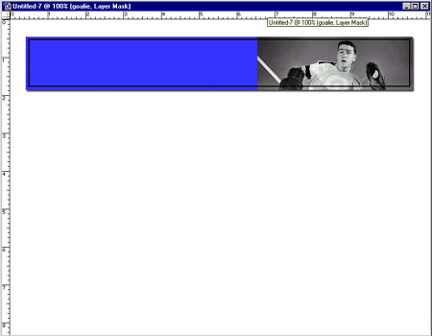

- Now modify the image layer of the goalie using the dropdown menu on the layers palette and change the mode to “luminosity”.

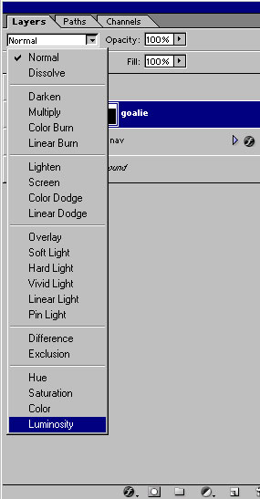

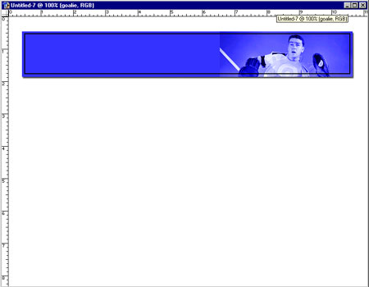

Select the mask portion of the layer so you have the “mask icon” to the right of the “eyeball”. If you have a “paint brush” you have not selected the mask.

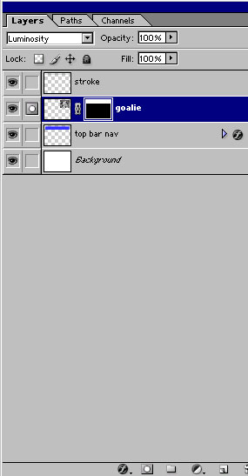

Set the main color to black on the color selector and with the brush tool set to airbrush smooth out the edge of the image.

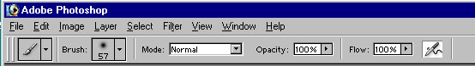

You can modify the size, opacity and flow of the airbrush to get the desired effect you want.

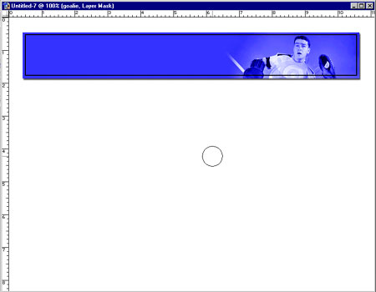

Next, import the grid into the file.

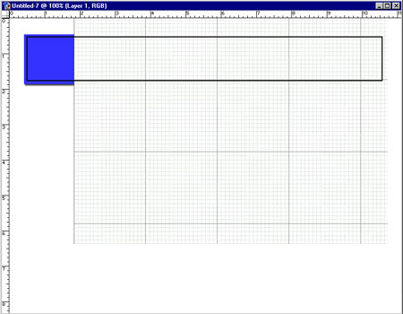

The grid should be below the stroke but above the image and the top bar nav layers.

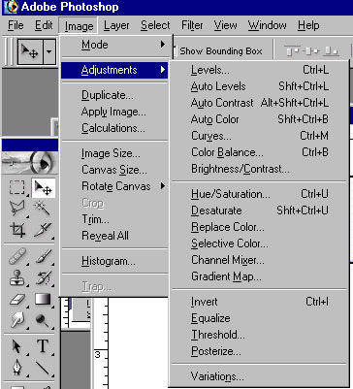

Next, invert the grid image. Using Image > Adjustments > Invert

Then using the drop down on the layers palette, change the mode of the layer from normal to screen.

The end result should be something like this.

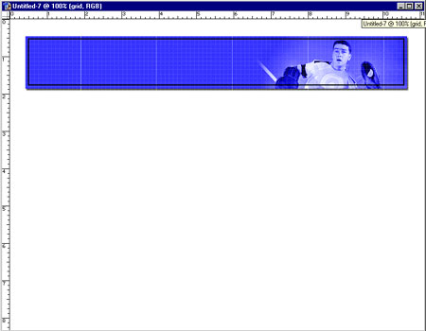

The layers should look something like this.

