- Click Start, point to Programs, point to Accessories, point to System Tools, and then click Backup.
- Click Backup Wizard, and then click Next.
- On the What to Back Up page of the wizard, click the appropriate option for the data that you want to save, and then click Next.
NOTE If you click Back up selected files, drives, or network data, a dialog box is displayed in which you can select the drives, folders, and files that you want to back up. If you want to back up the entire computer, including the system state, click Back up everything on my computer.
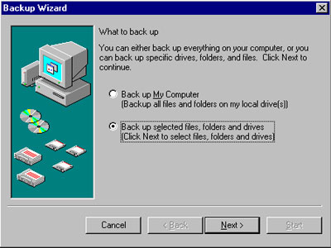

- On the Where to Store the Backup page, click the location (file or storage device) where you want to store the backup, type the name that you want to use to identify the backup in the Backup media or file name box, and then click Next.
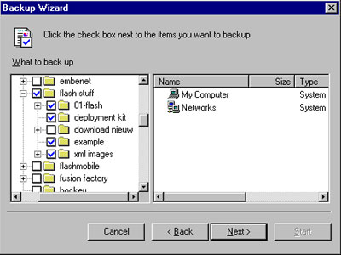
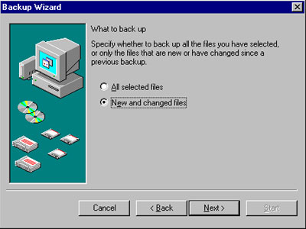
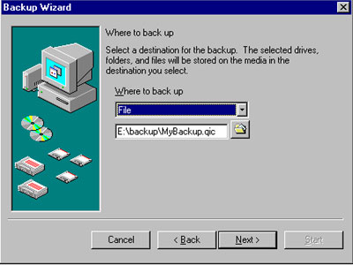
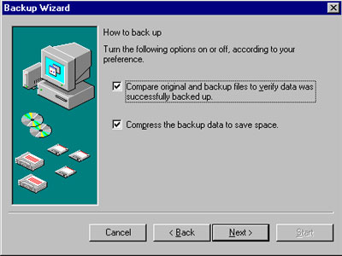
- Click the Advanced button.
Additional backup options are displayed, including the scheduling options. In the following dialog boxes, enter the appropriate information:
  - Type of Backup
  - How to Back Up
  - Media Options
  - Backup Label
- If you want to start the backup job immediately, when the When to Back Up page is displayed, click Now, and then click Next.
- To schedule the job, click Later, type your credentials in the dialog box that is displayed, and then click OK.
- Type a name in the Job Name box, and then click Set Schedule.
- When several options are displayed, including Schedule Task, Start Time, and so on, enter the appropriate information, and then click OK.
- Verify the start date, and then click Next.
- Click Finish.
- To view or make changes to the scheduled job, click the Scheduled Jobs tab on the main Backup dialog box, and then double-click your selection. Alternatively, double-click Scheduled Tasks in Control Panel.

