From: http://mysite.wanadoo-members.co.uk/BBGorB/tutorial01.html but please do not go there and use the second part – it is older Flash…
A step by step guide to build a flash Audio Spectrum analyser v.2

Introduction
This tutorial will cover how to build a simple Audio spectrum analyser in flash with the help of other audio tools. Getting Started There are two audio toolz you'll need to download in order to follow this tutorial:

Spectrum Laboratory
This is a program that lets you analyse your .wav and generate log file that contains spectrum data needed for our flash spectrum analyser.
This freeware can be downloaded from here. You'll also need to download Borland's VCL40.BPL if you don't already have it on your PC. After you have downloaded it, extract VCL40.BPL to your X:\windows\system\ directory.
If you want to know more about this program, please visit their web site at http://www.qsl.net/dl4yhf/

dBpowerAmp Music Converter
With this program you can convert .mp3 files to .wav and vice versa. Go to their web site to download this handy converter.
When you have finished installing the above toolz, convert all the sound files to .wav with sampling rate set to at least 16,000HZ.

Source File
You also need to download the source files and a converter included in source.zip to proceed this tutorial.

How it works
The spectrum analyser we are about to build here is NOT a realtime analyser, All the spectrum data are pre-recorded, processed and dumped into flash.
In this tutorial, we use spectrum lab to obtain spectrum data. Spectrum data is a row of numbers separated by commas, their value range from -199 to 0 which represents the amplitude of specific frequency bands, these numbers are recorded in a log file at predefined intervals. Spectrum Data of a particular interval (one Row) looks something like this:
-17,-51,-55,-62,-65,-66,-64,-68,-69,-69,
Data in the log file can be interpreted in a two dimentional array, in In order to optimise performance, we need to collapse the two dimantional array into a string of single digits, we convert the range -199 - 0 to 1- 9, for example:
2368169543
we also need to know the number of frequency bands (the number of moving bars) and the number of rows (i.e. total number of intervals recorded), in order to extract data of a specific frequency band at a specific time interval from the string.
Once the spectrum data is declared, we can use its value to set level of each bar. The pseudo mechanism goes like this:
1. Plays the sound
2. Find out in millisecond how long the sound has been playing
3. From 2, find out the corresponding time interval (the row number)
4. For each bars in the spectrum analyser, lookup the corresponding amplitude value using result obtained in 3, and adjust the bar level with the value.
5. If the interval is greater then the last row number, stop the sound and exit, else repeat 2-5.

Using Spectrum Lab to generate spectrum data
Spectrum Lab is a specialized audio analyser, it has many advance features, amongst which the powerful data logging feature. It allows you to set the interval in miliseconds at which data is written to the text file and how many frequency bands you want to log and their amplitude range.
This tutorial will only cover up to what you need to obtain the spectrum data. The rest are left for you to explore.

Setting up Spectrum Lab
You can do the setup manually as shown below, or you can use the setting files included in source.zip
Using setting files
- Back up "Mconfig.ini", "Settings.ini" and "curent.edf" in the Spectrum Lab directory. (optional)
- Go to "SpectAnaSetting" directory in the source.zip, copy "Mconfig.ini", "Settings.ini" and "curent.edf" and paste them into your Spectrum Lab directory.
- Open Spectrum Lab, go to "File" -> "Text file export" -> "Filename & Activation", type in the path of your log file e.g. C:\WINDOWS\DESKTOP\spectData.txt next to "Data File:" then press "OK".
Doing it manually
open the Spectrum Lab program, go to "option" -"audio setings" as follows:
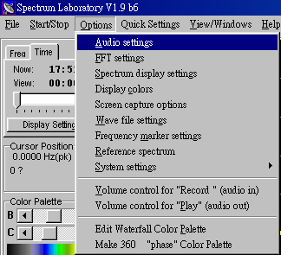
The configuration and display control panel comes up, set the sample rate to 44100Hz or 22050Hz, just make sure it's over 16000Hz.
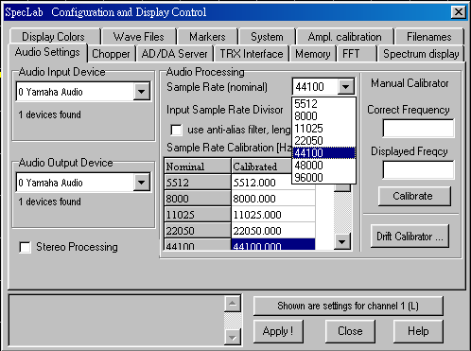
Then in the same panel, go to Spectrum display and type in "93" under Waterfall Scroll Intv., make sure it's in millisecond. You can try out other values for the interval, the smaller the value is the largerer the text file it generates. A 1 min track analysed with 93ms interval results in a 14K text file which took 3 seconds for a 512M Ram PII 400MHz to load the file, just over a second in a PIII 1.2GHz, whereas 100ms interval yields a 8K txt file, and 90ms yields 27K
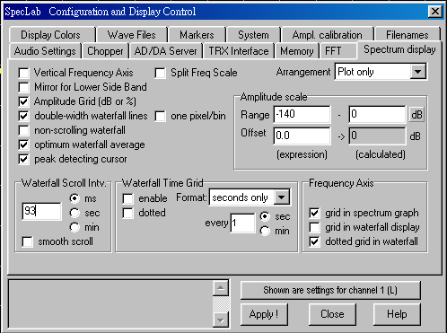
In the same panel again, go to the Wave setting change the speed under the "File Analysis w/o audio reply" to Fast. Choosing this setting will speed up the analysing time, it does not affect the output of the log file.
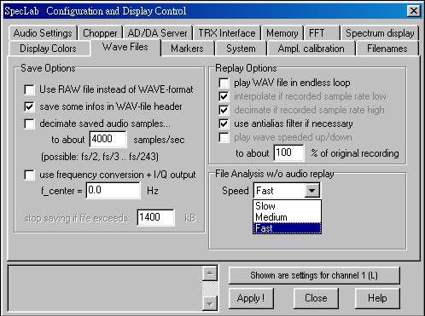
After setting up the Spectrum Laboratory, we have to define the format of the output data, go to "File"-"Text file export" then the "File Contents" section and enter the parameters as follows:
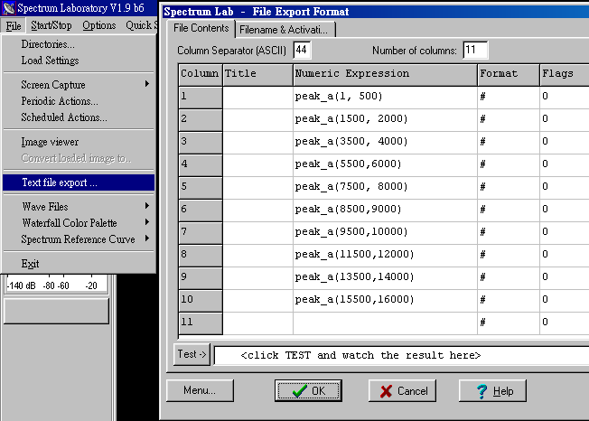

Generating the Data File
When you are ready to analyse the wave file, go to the "File Export Format" panel (same as above) and go to the "Filename & Action" section. Enter the path and file name of the data file then check the Active check box to toggle the output mode. When the box is checked, the data file is locked and ready for data logging, and only Spectrum Lab can write data to the file. Spectrum lab append data to the end of the file, so make sure the data file donesn't contain spectrum data from previous runs.
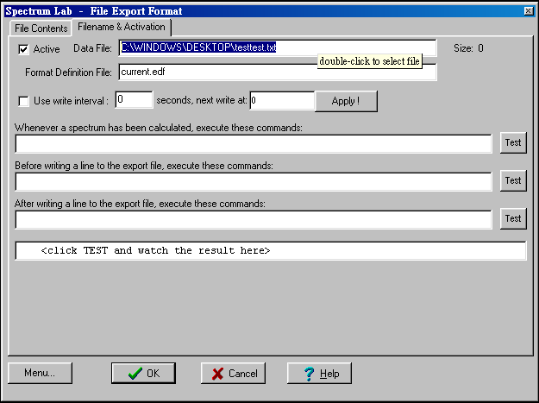
Now every thing is ready, make sure you have activated text file export then go to "File"-"Wave Files"-"Analyze input from *.WAV-file", the audio File analysis panel will pop up. Now choose 1024 pts for the FFT option and press ok, you will see the spectrum graph starts to jump. it finishes analysing the wav file when the graph stops moving.
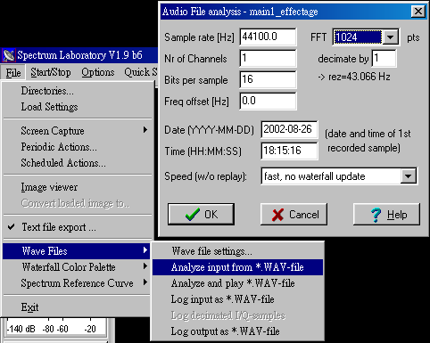
Open the data file in notepad, you should see some thing like this:
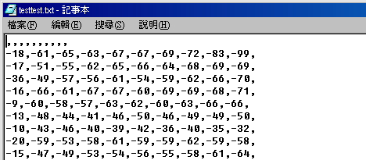
Replace the first line which says ",,,,,,,,," with "sdata=" (without the double quotes), and add "&loadstatus=1" to the last line, make sure there are no carrage returns nor spaces after that and save the the file:

