MOTION TWEEN ON A PATH USING A GUIDE LAYER
The guide layer lets you animate a motion tween along a path drawn by the Pen, Pencil, Line, Circle, Rectangle, or Brush tool.

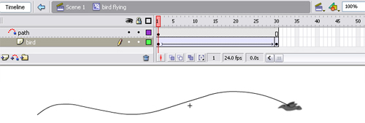

- Create a motion-tweened animation sequence using basic tweening techiniques.

- Select the frames of the tween and in the properties panel you can select Orient to Path to make the baseline of the tweened element will orient to the motion path. If you select Snap, the registration point of the tweened element will snap to the motion path – which is desired.

- Select the layer containing the animation and choose Insert > Motion Guide or right-click the layer containing the animation and choose Add Motion Guide from the context menu.

- Use the Pen, Pencil, Line, Circle, Rectangle, or Brush tool to draw the desired path or paste a path onto the motion guide layer.

- Drag what you are animating by its registration point and snap it to the beginning of the line in the first frame, and to the end of the line in the last frame.

- Now when you scrub or play you should see the object follow the path. If you do not then make sure that you snap your object to the line – this can be tricky. Also make sure you have a tween.

- You can add layers or take layers away by dragging them in or out of the guide layer's influence much like mask layers.

