BASIC AFTER EFFECT STEPS
Let's build a quick title composition where we move a picture behind some fat title text. We'll have a divider line that is made up of the same picture masked with a thin rectangle to appear like a line. We'll have some sub text fade in and hold. This will be similar to the intro of The Ride Theory example.

PART 1 – MATTE (Like a Mask)
- Open After Effects and start a new project from File > New > Project.
- Then choose Composition > New Composition - this would be one of many compositions.
- Name the composition "title" and choose a size, etc. and note that you set a length of the composition as well. You can change this later by choosing Compositions > Composition Settings.
- A Timeline panel and Composition window appear.
- Create a new solid for the background color by selecting Layer > New > Solid.
- Then add the text for your title by selecting Layer > New > Text or using the text tool in the Composition window. Make the text big enough to see a picture through. Make the title text relevant to your picture you are about to bring in.
- Import a picture – for instance a jpg by dropping it into the Project panel or File > Import > File.
- Drag the picture to the Composition window or into the Timeline. It will show up in both regardless.
- If necessary, drag the title of the layer to the level below the text.
- Under Switches / Modes at the bottom of the timeline, toggle Modes to show.
- This allows you to set the Track Matte from none to Alpha Matte.
- The picture should show through the above text with the text layer having its eye icon removed.

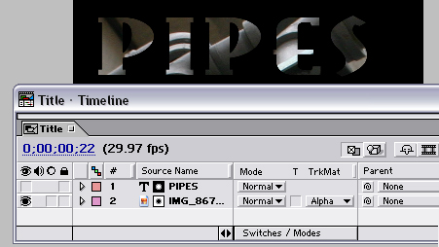

PART 2 – ANIMATING THE PICTURE
- Drag the picture to a good starting position on the left (you will want to pan to the right).
- Expand the picture layer and the Transform properties.
- Make sure the current time indicator is at the start (home button).
- Click the little clock near the position property and you will see a keyframe be added.
- Move the current time indicator along to the right a few seconds and move the picture to the right.
- A second keyframe will be placed - scrub the timeline to see the picture moving in behind the text.
- Use the arrows at the left of the layer to go to the keyframes (pick up the keyframes to move them)
- Expand the Position property and you can see the linear speed curve.
- Test the animation with the play button of the timeline controls or with the spacebar
- Set the first keyframe to ease out and the second to ease in by right clicking them and selecting Keyframe Assistant > Easy Ease Out and then Easy Ease In to the ending keyframe.
- Note the speed curve changes to show the easing.

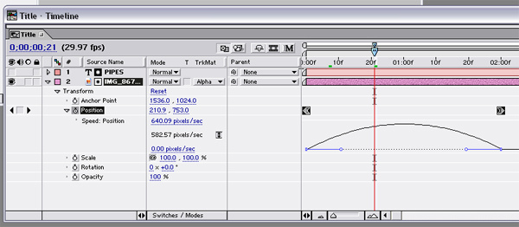

PART 3 – MASK LINE
- Add the picture again on a layer beneath the previous image.
- Make sure your picture is slid in the timeline to the very left (use the shift key as you drag to snap)
- With the rectangle tool from the Tool palette, draw a thin line in the Composition window.
- This rectangle becomes a mask for the layer.
- If you move the layer, the mask moves too. Use the Pan Behind tool to pan the picture in the mask.
- You can animate the picture in the mask this way to but we are not going to.

PART 4 – FADING IN TEXT
- Switch to the text tool and write some text that relates to your topic as a sub heading.
- Click on the clock next to the Opacity property to set a keyframe
- Use the context slider to slide the opacity to zero.
- Position the time indicator to just before the previous animation finishes.
- Click the check box near the arrow at the left of the opacity property to add another keyframe.
- Then move the time indicator a second more along and add another keyframe.
- At this last keyframe slide the opacity up to 100.
- Scrub the timeline to see the opacity stay at 0 and then increase linearly.
- Change the increase to ease out and ease in.

