AFTER EFFECTS BASICS
After Effects is a video compositing and effects tool. It lets you put layers of video, text, pictures, shapes and sounds on top of or next to each other (compositing). You can mask and matte and blend these layers. You can apply a series of effects from basic properties like position, size and opacity to adjustments like color and contrast and on into complex effects like rendered patterns, and 3D lighting.

A main strength of After Effects is that all these properties and effects can be animated in time along a time line with keyframes, tweening and scripting.

LAYOUT
After Effects is similar to Adobe Flash and Premiere in its layout. It has a project panel (library), a composition window (stage or monitor) and a timeline with layers and frames – and a variety of tool, control, effects, property, render and sound pannels, etc.

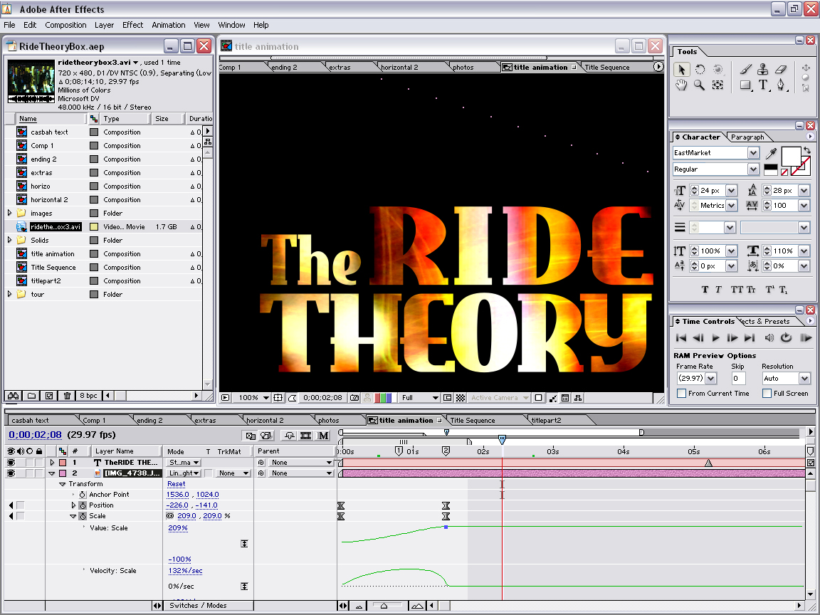
figure 1

BUILDING A PROJECT IN AFTER EFFECTS

Open a new Project and then a new Composition. A Composition is like a Sequence in Premiere or perhaps a MovieClip or Scene in Flash. When you make a Composition it shoes up as a tab in the timeline pannel and gets its own timeline. You then add layers to the composition such as text, solids, video, or other compositions. You can create layers from the layer window or drag things from the project pannel which holds your assets.

AFTER EFFECTS TIMELINE
The timeline in after effects is a bit different – you add only one object on a layer. You can adjust that object along the layer but usually, you just hide it by dropping its opacity when you don't want to see it.
You have fairly traditional control of the timeline – you can lock layers and hide them from view. You can put markers along the top both for the timeline and the specific layer. These help to snap things into position or coordinate animation. You can zoom in on the timeline and adjust its workspace with sliders etc. Layers higher up are on top and you can drag them to different levels (drag their titles).

LAYER PROPERTIES
There is a lot of information in a layer that you can view and change by clicking the little arrows and expanding the properties. These will give you transform control of position, size, rotation, alpha, etc and text properties. And when you add a mask and effects, you will be able to expand those as well. You change properties by using the provided context slider or typing in a number. Some will be changed by adjusting the property in the composition window (like moving some text for instance).

ANIMATING PROPERTIES
You can animate a property along the timeline by clicking the little stopwatch next to the property. Then when you change the property a keyframe will be added and it will change the property at that point in time. Once a keyframe has been added, you can navigate them with the arrows at the left of the pannel and you can add or delete keyframes using the check box by the arrows or the delete key.

figure 2

TYPES OF KEYFRAMES
Different keyframes affect the way the property animates between the keyframes.
Linear: makes the property tween in a linear manner from one keyframe to the next
Hold: makes the property stay the same
Bezier: eases the property in or out or in and out
Conitinuous Bezier: makes the bezier handles tangent to the easing for smooth in and out
Auto Bezier: makes the in and out easing equal
You can adjust these by right clicking on the keyframe and selecting Keyframe Interpolation. There are also animation helpers to quickly ease in and out – this will turn the keyframe into a bezier keyframe.

FINE TUNING ANIMATION
By expanding your property with the little arrow, you can see the property's value and velocity scales or graphs (see figure 1). You can drag the bezier curves to affect changes. The velocity is how fast the change takes place and the scale is how much change takes place. These to graphs affect each other.
To make animations within animations you can put a first composition with an animation inside a second composition and then animate the properties of the first composition. Like nesting MovieClips in Flash.

MOTION PATHS
You can create a motion path just by positioning an object and setting a keyframe then adjusting the current time indicator and dragging the object in the composition window to another place. A path is drawn that you can then adjust with the bezier curves in the composition window. You can also do a motion sketch under Window > Motion Sketch. You can smooth curves by selecting all the keyframes and then selecing Window > The Smoother. It is well worth using these tools.

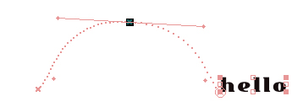

MASKS, MATTES AND BLENDS
You can make a mask for a layer which will show only what is behind the mask. Alternatively you can set a second layer as a matte for a first layer an and the first layer will show through the matte. And you can apply blend modes on layers to blend with the layer(s) beneath.

MASKS: To make a mask for a layer, select the layer and then use the rectangle, oval or pen tool to draw a shape in the composition window ontop of the layer. You can adjust this shape with the bezier curves or click on it with the select tool to move it, resize or transform it. The mask(s) show up as a property of the layer near the transition properties. Use the Pan Behind tool to move the layer underneath the mask and keep the mask in the same position. You can also animate the motion of the layer in behind with keyframes and the Pan Behind tool.

To use text as a mask, right click a text layer and select Create Outlines. This makes a new layer with a bunch of masks in its properties. Copy these masks to another layer to use them as a mask for that layer.

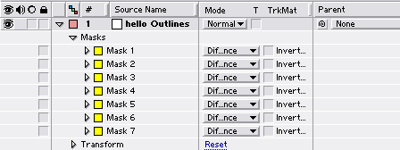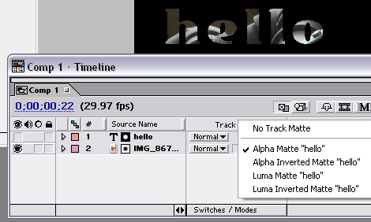
figure 3. masks figure 4. mattes

MATTES: Mattes are like masks except you use two layers. The matte (like a mask) goes on top and then the layer you want to see through the matte goes on the bottom. To set the top layer as a matte, make sure that your switches / modes tab at the bottom of the timeline is set to modes. Then on underneath layer under trkMat choose the type of matte. An alpha matte will show through anything where the top layer has a color (is not transparent) and a luma matte will show through where pixels are brighter than the underneath layer.

BLENDS: Blends work similar to photoshop blends and can be selected from the modes column.

