MODULE 4: Sketches and Plansds

WIREFRAME DIAGRAMS
You plan your project with a wireframe diagram. Wireframe really just means drawing boxes around interface and content areas. You then label these and draw arrows between different states (views) or pages of your project.
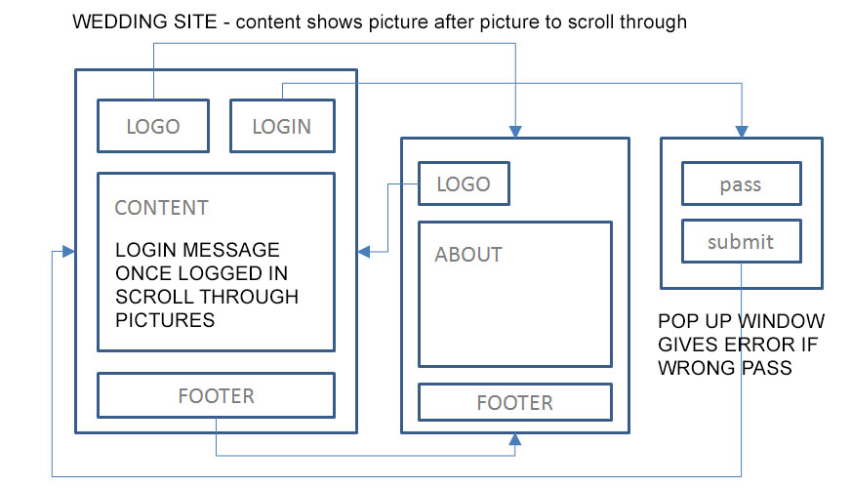
WHY
You want a plan so that you have a clear vision of what you are building. The plan often will often allow you to avoid problems that you might not see otherwise.
HOW
Start with paper and pencil. This allows you to draw as quickly as you think whereas on a computer, it is not as easy to draw and label. With a pencil you can easily erase. For presentation to your boss or a client you may want to create digital presentation in PowerPoint or a wireframing program (just search Google for wireframe program).
WHAT
Each navigation area and content area should have its own box and be labelled. Each button should have a box and an arrow to the screen the button will take the user to if applicable. There should be a title at top and descriptions around the sides of any non-obvious behaviour. Try and fit all screens on one page for a small to medium size application. Wireframes can also be used to show the hierarchy of navigation through a site or application screens.
https://www.google.ca/search?q=sketch+wireframe+diagrams&tbm=isch

